Anonymous Company
Always (L)earning

Otilia Marinescu
University of Salford

Table of Contents
- Abbreviations .................................................................................................................. 2
- Introduction ..................................................................................................................... 3
- Anonymous Company Corporate Social Responsibility …......................................... 3
Anonymous Company and the CSR Pyramid ........................................................................................... 3
Anonymous Company Stakeholder Approach ........................................................................................ 5
- Sustainable Development Goals at Anonymous Company....................................... 8
Sustainability and the UN Sustainable Development Goals
(SDGs) .................................................................................................................................................................... 8
Quality Education (SDG 4) ................................................................................................................................. 8
Reduced Inequalities (SDG 10) ......................................................................................................................... 9
- Conclusion .................................................................................................................... 10
- Reference List ................................................................................................................ 12
- Appendix A – My World UN Global Survey Results .................................................... 15
- Appendix B – Global South / North ............................................................................. 16
- Appendix C – Anonymous Company Stakeholder Engagement ............................ 17
Anonymous Company engagement with some of its key stakeholders ............................................. 17
Anonymous Company Material Issues .................................................................................................... 18
- Appendix D – Standardized Testing ............................................................................ 19
Overview of Standardized Testing .................................................................................................................. 19
Cost of Standardized Testing ........................................................................................................................... 20
Impact on Educators ........................................................................................................................................ 20
- Appendix E – Anonymous Company SDGs focus .................................................... 21
- Appendix F – Education and the SDGs ....................................................................... 22
- Appendix F – Fairness of Standardized Testing .......................................................... 24

1

Abbreviations

CSR | Corporate Social Responsibility
DfID | Department for International Development
EFA | Education for All
LFPS | Low Fee Private Schools
NYSAP | New York State Allies for Public Education
ALF | Anonymous Affordable Learning Fund
SDG | Sustainable Development Goal
UN | United Nations

Abstract

Corporate social responsibility (CSR) and sustainability have seen a rapid evolution in the past 2 decades (Blowfield & Murray, 2014), becoming increasingly important for businesses of all sizes (Thirumuru & Thirukkovela, 2015). Their role is even more significant for Anonymous company, whose actions as the major private player in global education could have a significant effect on shaping the future of society. This paper therefore aims to evaluate Anonymous company business strategy with regards to the two concepts. The first part of this report will use the CSR Pyramid and the Stakeholder Theory to assess their position as a “socially responsible business”, while the second part will focus on their actions towards the 2 UN Sustainable Development Goals most relevant to Anonymous company – Quality Education and Reduce Inequalities – and offer recommendation for the future.

Introduction

Education is one of the key pillars of modern society and its importance was recently globally reinforced when over 6.5 million people from all over the world chose “a good education” as the most important issue for them and their family (United Nations, 2016) – see Appendix A. The education industry has seen a rapid growth in recent years, as a result of more and more governments appealing to private companies to solve their various education problems (Ball, 2012). One of these is Anonymous company, the world’s largest education company, which operates in over 70 countries (Anonymous company, 2016) and plays “a key role in steering education policy, developing curriculum and assessment, and even running schools” (Education International, 2016).
Corporate social responsibility (CSR) and sustainability have seen a rapid evolution in the past 2 decades (Blowfield & Murray, 2014), becoming increasingly important for businesses of all sizes (Thirumuru & Thirukkovela, 2015). Their role is even more significant for Anonymous company, whose actions as the major private player in global education could have a significant effect on shaping the future of society. This paper therefore aims to evaluate Anonymous company business strategy with regards to the two concepts. The first part of this report will use the CSR Pyramid and the Stakeholder Theory to assess their position as a “socially responsible business”, while the second part will focus on their actions towards the 2 UN Sustainable Development Goals most relevant to Anonymous company – Quality Education and Reduce Inequalities – and offer recommendation for the future.

Anonymous Company Corporate Social Responsibility

Anonymous Company and the CSR Pyramid

Theoretical Background
CSR represents the voluntary inclusion of public interest into the business strategy (Panayiotou & Aravosis, 2011) and it can be viewed as a “contract with society” (Ferrell, Fraedrich & Ferrell, 2015,
p. 36). CSR covers the whole range of business responsibilities, which can be split into 4 main categories: economic, legal, ethical and philanthropic (Carroll, 1991). The relationship between these is illustrated through Carroll’s (1991) CSR Pyramid, which can be seen in Figure 2.

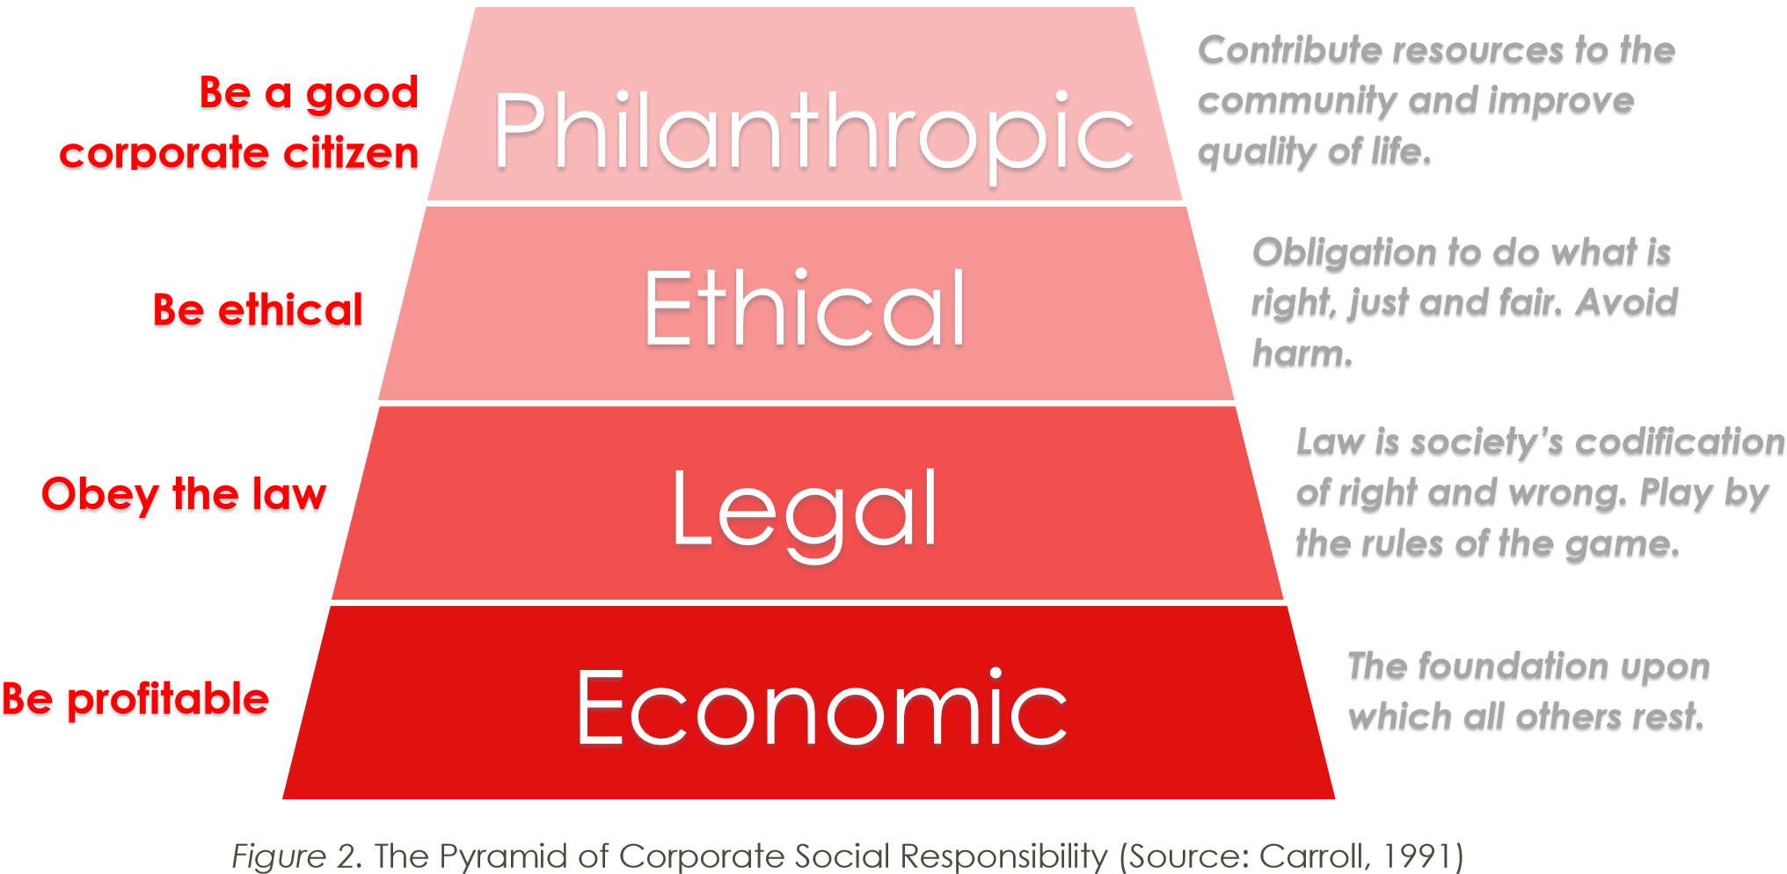

The remainder of this section will see and application of Carroll’s (1991) CSR model to one of Anonymous company business activities – the Affordable Learning Fund (ALF) – with a particular focus on their Economic and Philanthropic responsibilities.

The Affordable Learning Fund (ALF)
The Affordable Learning Fund (PALF) is a commercial fund with the purpose of supporting low-fee private schools (LFPS) in the Global South (Riep, 2015a) – a detailed definition of the Global South/North can be found in Appendix B. It was launched at 2012, the total investment up to date reaching $65 million (Anonymous Company, 2015a).
Despite it being a commercial fund, Anonymous company claims that their investment in low-fee private schools is grounded in the charitable aim of providing a better education to students in developing countries: “Our vision is to help millions of children in the world access a quality education in a cost effective, profitable and scalable manner” (Anonymous Company, 2015b, para. 1). This fund therefore aims to particularly address 2 of the 4 social responsibilities identified by Carroll (1991): philanthropic, through the quality, cost-effectiveness and location of the low-fee private schools supported and economic, by being profitable.

Philanthropic Responsibilities
At first sight, ALF seems to be beneficial for millions of poor and families from developing countries.
However, the “affordability” of these low-fee schools is misleading (Department for International Development, 2016; Downs, 2016). One of the many examples is the Omega Schools chain in Ghana, charging approximately $140 per child per year (Riep, 2015a), which amounts t0 40% of the poorest households’ total income (Candela, 2016). This often results in discrimination, as boys’ education is given priority over girls (Tran, 2012). As UNESCO (2015, p. 65) observes: “Where access depends on paying fees, many of the poorest are left behind”. This proves that ALF actually does more harm than good, taking advantage of vulnerable families in order to make a profit (Singer, 2016). Therefore ALF not only goes against Anonymous company philanthropic responsibilities which it claims to address, but also raises questions regarding their ethical responsibilities.

Economic Responsibilities
One of ALF’s main objectives is to “develop new markets and sources of profitability in the lowcost private school sector” (Riep, 2015b, para. 2). This follows Prahalad’s (2005) ‘bottom of the pyramid’ scheme, according to which the fastest growing market is among the poorest, who have a collective unexploited buying power. In 2015, Anonymous company made an additional investment of $50 million to PALF, proving that the fund is a success in terms of profit. The key to this is the use of scripted standardised lessons which teachers read word for word (Junemann & Ball, 2015). This allows them to employ teachers with no college degree, who are being paid 50% less than the average salary of a public school teacher (Riep, 2015c). Consequently, despite fulfilling their economic responsibilities, Anonymous company should reconsider the impact of its profit-making strategies on the vulnerable communities it claims to be helping.

Anonymous company Stakeholder Approach

Theoretical Background
The stakeholder theory originates in the 1980s, when Freeman (1984) argued that, for a business to be successful, it should consider and act upon the needs of all its stakeholders, and not just its shareholders. He defined a stakeholder as “any group or individual who is affected by or can affect the achievement of an organization’s objectives” (Freeman, 1984, p. 5). Freeman’s (1984) theory provided a new angle on organisational responsibilities. By implying that a certain level of satisfaction needed to be achieved from all stakeholders in order to fully serve its shareholders, the theory generated a shift in the organisational considerations, making them go beyond profit maximisation (Jamali, 2008).

Figure 4 (ConceptDraw, 2016) illustrates the different stakeholder layers and groups:
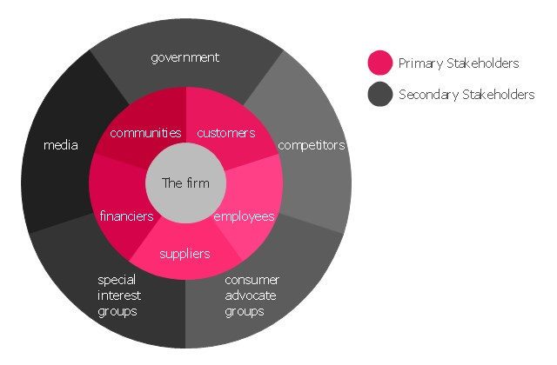
Figure 4.
Stakeholder
Groups (Source: ConceptDraw, 2016)

Anonymous Company Stakeholders
In their latest sustainability report, Anonymous company (2015c) identified and classified the following stakeholder groups and concerns (Figure 5):

The diagram recognises 9 key stakeholder concerns, which Anonymous Company names “Material Issues”. Extracts from their 2015 sustainability report detailing these can be found in Appendix C. As can be seen from the diagram, there are 4 issues related to the education industry which represent very high concerns of stakeholders, however they are not chosen as key material issues.
This section will look into the high stakes testing issue (see Appendix D), which has the highest business impact of the 4. Anonymous Company ran 50 million standardized (high stakes) tests in 2015, despite evidence suggesting that these “narrow and simplify curricula, undermining both teaching and learning” (Education International, 201, p. 3). As a result, this analysis will focus on the 2 key stakeholders affected by these tests – learners and educators.

Learners
There is, once again, a lot of contradiction between Anonymous Company claims and its actions. One of the company’s key material issues is ensuring the health and safety of its learners (see Appendix C). However, research suggests that 33% of US students experience some anxiety related to standardised tests (a market dominated by Anonymous Company), one third of them reporting “severe psychological and physiological symptoms” (Parents Across America, 2015). Anonymous Company is aware of the issue, however their approach shows a lack of care for the students. Instead of making changes to their tests, the company included official instructions for test administrators on how to deal with students vomiting their test booklets (Oliver, 2015). The increasing boycotting of these tests is the final proof that Anonymous Company does not pay as much attention as it claims to learners’ needs – 265,000 students refused to take part in the New York State 2016 standardized assessments, a 10% increase from 2015 (NYSAPE, 2016).

Educators
When it comes to teacher engagement, Anonymous Company approach does not see any improvements (see Appendix D). One of the main issues with their standardized tests is the lack of transparency. Educators administering the tests are forced to sign a contract with a confidentiality agreement which prohibits them from ever discussing or revealing any of the questions (Phillips, 2014; Strauss, 2014). While this is allegedly done to prevent cheating, the confidentiality agreement is very broad and goes beyond the exam taking period. This goes against the very purpose of teachers, who cannot provide students with feedback or even point out any problems with the questions. This lack of transparency has caused many teacher protest rallies and online petitions, including a letter sent by the American Federation of Teachers to the executives of Anonymous Company (Magee, 2014).

Sustainable Development Goals at Anonymous Company

Sustainability and the UN Sustainable Development Goals (SDGs)
According to the Brundtland Commission (1987, para. 27), sustainable development “meets the needs of the present without compromising the ability of future generations to meet their own”. Sustainability is based on a company’s impact on 3 main areas – economy, society and environment (Levett, 1998).
On the 25th of September 2015, the UN adopted a new set of 17 sustainable development goals to be reached by 2030, which address the 3 components suggested by Levett (1998): to end poverty (economy), to protect the Earth (environment) and to ensure prosperity for all (society) (United Nations, 2015). As a founding signatory of the UN Global Compact, Anonymous Company has aligned its sustainability strategy with the SDGs, identifying the 3 areas where they can make the most impact: Quality Education (SDG 4), Decent Work and Economic Growth (SDG 8) and Reduced Inequalities (SDG 10) – see Appendix E (Anonymous Company, 2015c). This section will focus on the company’s actions towards SDGs 4 and 10.

Quality Education (SDG 4)
According to the Global Partnership for Education (2015), education is essential to the achievements of all 17 SDGs (see Appendix F), being mostly relation to the society component of sustainability. For Anonymous Company, the world’s largest education company, Quality Education is not just an SDG – it summarises their entire mission. Since the adoption of the SDGs, the company has already initiated humanitarian projects and programmes addressing the issue of global education, such as Every Child Learning (in collaboration with Save the Children), which provides education for children in conflict and emergency settings, or Project Literacy, a global campaign dedicated to eradicating illiteracy around the world (Anonymous Company, 2015c).
While these initiatives show that the company is trying to address global issues and contribute to this SDG, some of its business activity stands in contrast. One example is represented by the low fee private schools previously discussed in the first section. Besides their underqualified teachers, these schools also have very high teacher-student ratios, with classes of 60-90 students (Education International, 2016), which have been proven to be less effective than smaller-sized classes (Schanzenbach, 2014). In addition, many LFPS lack teaching resources and facilities such as electricity, usually not meeting the standards of public schools (Stern & Heyneman, 2013). All the aforementioned factors prove that these schools are actually low quality in comparison to their public counterparts, and Anonymous Company therefore fails to address SDG 4 through its support for them.
Likewise, Anonymous Company standardized tests also raise quality concerns. Many of their tests contained typos, errors or confusing questions, as well as glitches that shut down testing in an entire state (Education International, 2016). Moreover, Anonymous Company recruited test essay scorers through ads on Craigslist, with only a Bachelor degree required in any field, offering productivity incentives that could potentially motivate scorers to be speedier and therefore focus less on marking tests that affect the future of so many students (Strauss, 2015).

Recommendations
It is clear that Anonymous Company business actions contradict their involvement in humanitarian project. One major recommendations for them would therefore be to first focus on the day-to-day for-profit activity and change their strategy to work towards the SDGs they support. For example, LFPS could charge less for their courses, a fee proportional to the average income of the local families, or hire qualified teachers and provide better facilities that would enhance the quality of the education delivered. In terms of high-stakes tests, Anonymous Company should implement a more effective quality control, in order to ensure the correctness and suitability of the questions, as well as remove the confidentiality clause. Allowing students and educators to discuss the content of the tests would enable learners to receive feedback and identify areas of improvement, which is the core of learning and quality education.

Reduced Inequalities (SDG 10)
SDG 10 calls for reducing inequalities both within and among countries, in terms of income, race, sex, age, disability, ethnicity religion or other status (United Nations, 2015). Anonymous Company approach is to address this goal through education, therefore the aforementioned humanitarian programmes supporting SDG 4 also work towards SDG 10 – Reduced Inequalities. However, unlike the previous goal towards which Anonymous Company already made some good contributions, the company’s business activity actually seems to be working against SDG 10 through their LFPS and standardized testing.
As previously discussed in the first section, Anonymous Company supports low-fee private schools in developing countries – however, these “low fees” can amount to up to 40% of a household’s annual income for just one child (Candela, 2016). In its report, DfID (2016) raised concerns regarding the fact that the services provided by Anonymous Company in the Global South (in the form of LFPS) cannot be accessed by the poorest 10%. This is also recognized by UNESCO (2015), who argues that private schools are very unlikely to be set up in less populated or remote areas. This means that, through its support for LFPS, Anonymous Company actually increases social inequity for poor and remote populations. Moreover, besides economical and geographical inequalities, Anonymous Company activity also indirectly encourages gender inequalities. Due to the high fees, parents cannot afford to send all their children to school, which often results in gender discrimination, with boys given priority. This is ironic and contradicts Anonymous Company partnership with NGO Camfed to support girls’ education in Africa (Anonymous Company, 2015).
Standardized testing, another key profit-making activity for Anonymous Company, has also been proven to cause inequalities and disfavour certain student groups – low-income students, African American students, special needs students, students in suburban areas and students from household where the first language is not English (Parents Across America, 2015) – see Appendix F.

Recommendations
It is clear that, despite claiming to support SDG 10, Anonymous Company initiatives to address the issue do not make up for the damage generated by its business activity. Two of its key profit generating projects – ALF and standardized testing – are clearly flawed and disregard the impact they have on the lives of the customers and their communities. A recommendation for Anonymous Company would therefore be to re-think these 2 projects and come up with a new strategy that will be more considerate of all its stakeholders. For instance, in the case of LFPS, Anonymous Company could offer grants for girls in order to encourage their attendance, or offer significantly lower fees for households that bring more than one child to school in order to stop forcing parents to make a choice based on money issues.

Conclusion

In a world where privatisation is increasing and big businesses are more and more influential in the delivery of public services, corporate social responsibility and sustainability are more important than ever. One of these big businesses is Anonymous Company, the biggest education company in the world. Through its business strategy and activity, Anonymous Company plays a major role in shaping the future of society, as education is a very powerful “weapon”.
While the company positions itself as socially responsible, placing the learner “at the heart of everything they do” (Kilburn, 2015), evidence suggests that its activity has had a negative impact on teaching and learning worldwide. From the Global South, where the low fee private schools supported by Anonymous Company increase inequalities and profit from poor vulnerable families, to the Global North, where high-stakes testing puts dangerously high pressure on both educators and learners, Anonymous Company activity has affected the lives and futures of millions of learners all over the world.
Looking at Anonymous Company claims and actions from both a CSR and a sustainability point of view, many stark contradictions were found. While both ALF and standardized testing are based on good principles, the way they are put into practice raises many concerns. From creating income and gender imbalances in already vulnerable and poor regions to secrecy-surrounded anxiety inducing standardized tests, this paper identifies a lot of areas of improvement for Anonymous Company.
It is true that the company did initiate and involve in several humanitarian programmes that help with some of the issues they actually contribute to. However, the need of these additional programmes proves that there is an underlying cause which has not been addressed. Based on the findings of this paper, the problem is Anonymous Company business strategy, which prioritises profit making over social good instead of having a balanced approach.
Luckily, all these have not gone unnoticed – students, teachers and parents are demanding change. It is now up to Anonymous Company to actually listen and engage with its key stakeholders in order to truly place the interests of learners at the heart of everything it does, as it claimed and aimed to all along.

Appendix – Assignment Brief

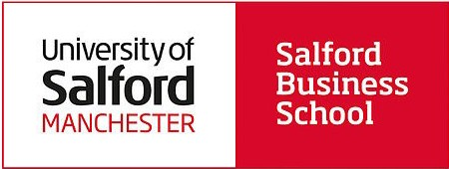

1

Business Ethics
and Sustainability
2016/17
Module Coursebook

CRN: 39286

  - Individual Written Assignment (60%) and Marking Criteria

As an individual, select a single company from the Britain’s Most Admired List 2015. (or see Appen- dix 1). Please note you will be asked to select this company in your seminar in week 4. Companies are not permitted to be selected by more than one student. By week 4 you should have explored and investigated the company of your choice (and at least one back up company).
When your company has been confirmed by your seminar tutor please answer the following assign- ment question:
    - Critically assess the company from the perspective(s) of business ethics or corpo- rate social responsibility (CSR) using two contrasting conceptual or theoretical ap- proaches.
    - Select two of the Unit ed Nat i ons Sust ai na-
ble Development G oal s (SDGs) and evalu- ate how the organisation is implementing these practices. Provide recommendations on how the company could improve further in these areas
Please ensure you have an introduction, then 2 sections (A and B) and a conclusion.
The range of material you analyse could include information provided by the corporation (e.g. sus- tainability / social / CSR policies and reports) as well as information about the corporation e.g. sto- ries in the media, including specific incidents (scenarios) the corporation has been involved in.

However, you must conduct your own analysis of the material. The detailed report guidelines will be provided during your tutorials. Written assignment will be marked equally out of 100. The word limit is 2500 words (10% above or under). Exceptions receive a 10% final mark penalty.

DEADLINE: 4pm – January 6th 2017
Source: sustainabledevelopment.un.org/sdgs
Feedback
You are entitled to feedback on your performance for all your assessed work. This is accomplished by a member of academic staff providing your mark and associated comments which will relate to the achievement of the module’s intended learning outcomes and the assessment criteria you were given for the task when it was first is- sued. This feedback will be available online via Turnitin. The marker of your assignment will in- clude feedback on written assignments that in- cludes answers to these three key questions:

- What is your overall feedback?
- How does your assignment compare to the mark- ing criteria?
3. How can you improve in the future?

Assignment Guidance
Reports will be marked based on the following criteria, please consider the following points:
- The adoption and analysis of suitable and relevant theory relevant to the company under investigation.
- Critical analysis should be included which explores the topics in question.
- Reports should answer the assignment question specifically
- A suitable report structure should be adopted.
- Both questions should be given a proportionate amount of preparation and have an equal word count.
- Valid arguments should be presented and support- ed with evidence.
- A coherent introduction and overall conclusions should be included
- All material must be reference correctly within the text itself (main body) (see page 27).
- A thorough and complete reference list must be included at the end of the essay in accordance to Harvard Standard (APA 6th).

Written Assignment

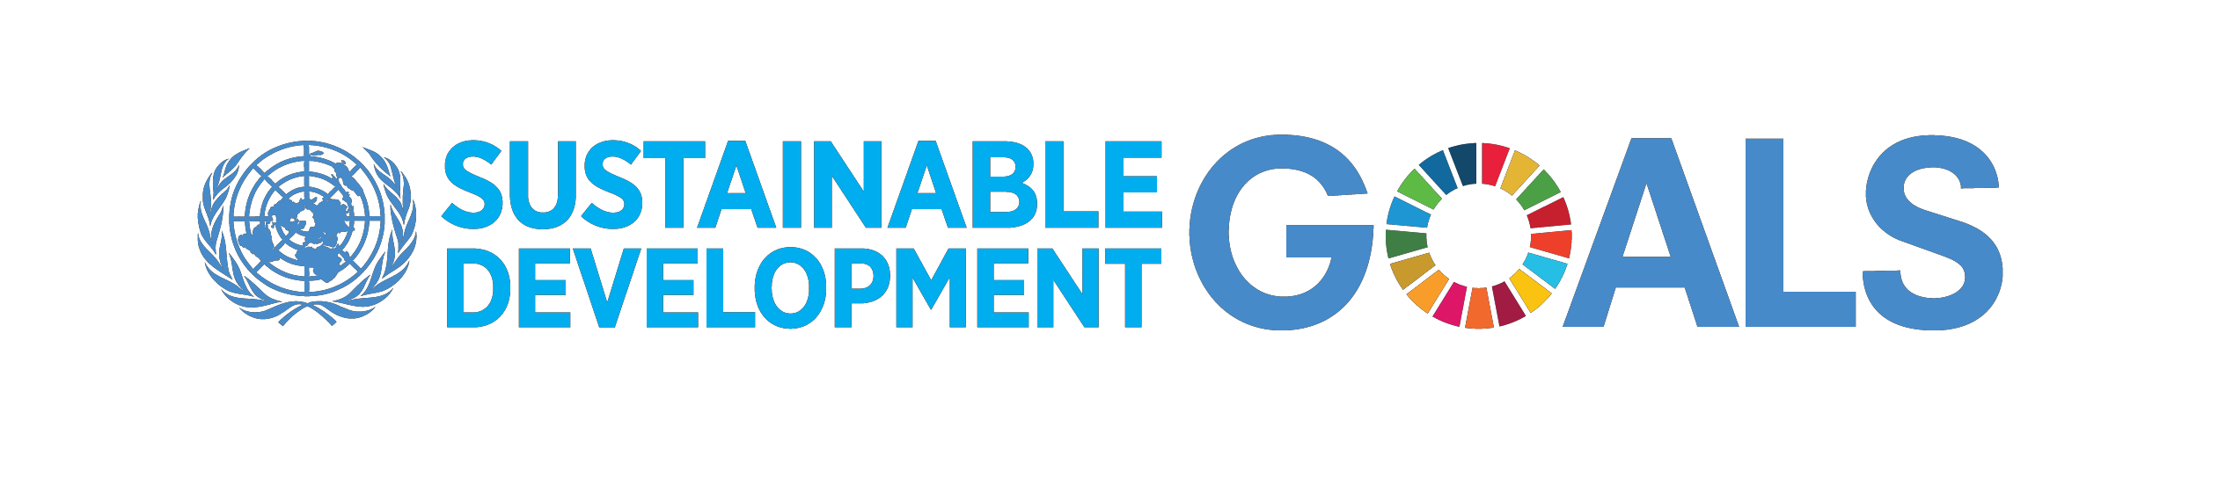
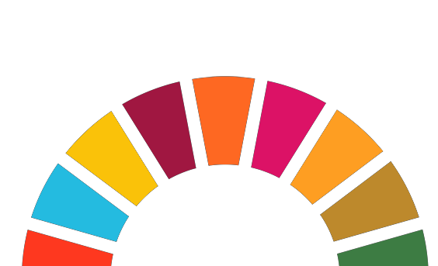

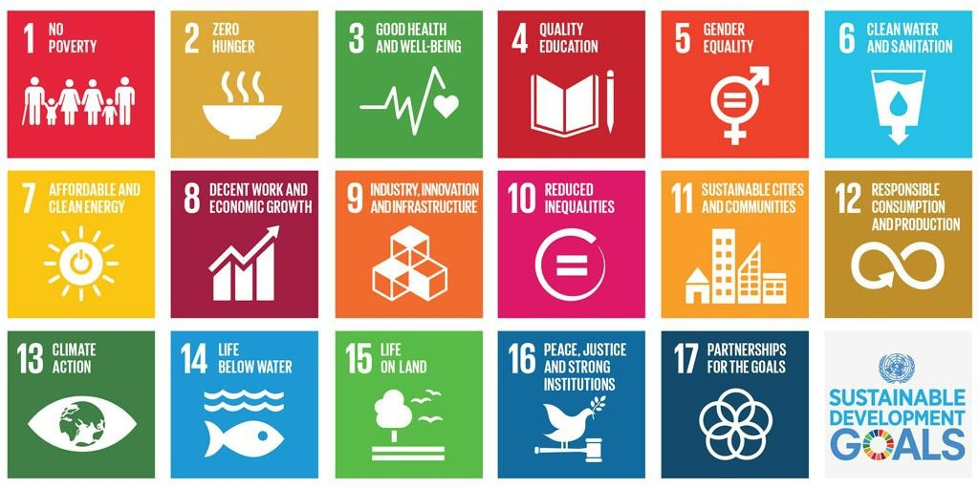

Reference List

Accredited Online Colleges. (n.d.). Tested: why standardized tests don’t make sense. [Infographic].
Retrieved from https://s-media-cacheak0.pinimg.com/originals/e3/42/a0/e342a03c4384a78cd5fbf71fbc478551.jpg
Ball, S. J. (2012). Global education inc: new policy networks and the neo-liberal imaginary. London: Routledge.
Blowfield, M., & Murray, A. (2014). Corporate responsibility (3rd ed.). Oxford: Oxford University Press.
Brundtland Comission. (1987). Our common future. Retrieved from http://www.un-documents.net/ourcommon-future.pdf
Candela, M. (2016, 13 April). Unmaking the market-maker: Anonymous Company in the Global-South. [Weblog]. Retrieved from https://www.unite4education.org/uncategorized/unmaking-the-market-maker-pearson-inthe-global-south/
Carroll, A. B. (1991). The pyramid of corporate social responsibility: toward the moral management of organizational stakeholders. Business horizons, 34(4), 39-48. doi: 10.1016/0007-6813(91)90005-G
ConceptDraw. (2016). Firm centric stakeholder diagram. [Diagram] Retrieved from https://conceptdraw.com/a68c4/preview/
Department for International Development. (2016). DFID’s programme in Nigeria: second report of session
2016-17. Retrieved from http://www.publications.parliament.uk/pa/cm201617/cmselect/cmintdev/110/110.pdf
Digital Media Diet. (2013). Is standardized testing fair?. [Infographic]. Retrieved from
http://digitalmediadiet.com/is-education-broken-the-problem-with-us-standardized-testing-in-publicschools/
Downs, J. (2016, 15 August). Uganda’s closure of Anonymous Company -backed academies raises questions re low-cost schools in global south. [Weblog]. Retrieved from http://www.localschoolsnetwork.org.uk/2016/08/ugandas-closure-of-pearson-backed-academies-raisesquestions-re-low-cost-schools-in-global-south
Education International. (2016). Pearson stakeholders’ report. Retrieved from http://download.eiie.org/Docs/WebDepot/Pearson%20Stakeholders%20Report.pdf
Ferrell, O. C., Fraedrich, J., & Ferrell, L. (2015). Business ethics: ethical decision making and cases (10th ed.). Stamford: Cengage.
Freeman, R. E. (1984). Strategic management: a stakeholder approach. Boston: Pitman.
Global Partnership for Education. (2015). Education and the global goals. [Infographic]. Retrieved from http://www.globalpartnership.org/multimedia/infographic/education-and-global-goals/
Jamali, D. (2008). A Stakeholder approach to corporate social responsibility: a fresh perspective into theory and practice. Journal of Business Ethics, 82(1), 213-231. doi: 10.1007/s10551-007-9572-4
Junemann, C., & Ball, S. J. (2015). Pearson and PALF: the mutating giant. Retrieved from http://download.ei-ie.org/Docs/WebDepot/ei_palf_publication_web_pages_01072015.pdf
Kilburn, D. (2015, 16 October). Graduating a nation. [Weblog]. Retrieved from https://www.pearson.com/news/blogs/CompanyBlog/2015/10/graduating-a-nation.html Levett, R. (1998). Sustainability indicators – integrating quality of life and environmental protection. Journal of the Royal Statistics Society: Series A (Statistics in Society), 161(3), 291-302. doi: 10.1111/1467-985X.00109
Magee, K. (2014, 25 April). Demand an end to Pearson's 'gag orders' on educators. New York State United Teachers. Retrieved from http://www.nysut.org/
NYSAPE. (2016). NYS Allies for Public Education. Retrieved 10 December, 2016 from http://www.nysape.org/
Oliver, J. (2015, 3 May). Standardized testing: Last Week Tonight with John Oliver (HBO). [Video file]. Retrieved from https://www.youtube.com/watch?v=J6lyURyVz7k
Panayiotou, N., & Aravosis, K. G. (2011). Supply chain management. In S. O. Idowu & C. Louche (Eds.), Theory and practice of corporate social responsibility (pp. 55-70). Heidelberg: Springer.
Parents Across America. (2015). How high-stakes standardized testing is harming our children's mental health. Retrieved from http://www.fairtest.org/sites/default/files/Test-Stress-FactSheet.pdf
Anonymous Company. (2015a). About PALF. Retrieved 9 December, 2016 from https://www.affordablelearning.com/about.html
Anonymous Company. (2015b). Vision. Retrieved 9 December, 2016 from https://www.affordablelearning.com/about/vision.html
Anonymous Company. (2015c). Transforming our impact: Anonymous Company sustainability report 2015. Retrieved from https://www.pearson.com/content/dam/one-dot-com/one-dot-com/global/Files/sustainability/2015report/full-2015-report.pdf
Anonymous Company. (2016). Who we are. Retrieved 9 December, 2016 from https://www.pearson.com/aboutpearson/who-we-are.html/
Phillips, E. (2014, 9 April). We need to talk about the test: a problem with the Common Core. New York Times. Retrieved from https://www.nytimes.com/
Prahalad, C.K. (2005). The fortune at the bottom of the pyramid – eradicating poverty through profits. Upper Saddle River: Wharton School Publishing.
Riep, C. B. (2015a). Omega Schools franchise in Ghana: a case of “low-fee” private education for the poor or for-profiteering?. Retrieved from http://www.periglobal.org/sites/periglobal.org/files/WP63%20Omega%20Schools%20Franchise%20in%20Gh ana.pdf
Riep, C. B. (2015b). Transnational venture capital and the rise of ‘low-fee’ private schools: the case of Pearson and Omega Schools in Ghana. NORRAG News, 52, 84-85. Retrieved from: http://www.norrag.org/fileadmin/Full%20Versions/NN52.pdf
Riep, C. B. (2015c). Corporatised education in the Philippines: Pearson, Ayala Corporation and the emergence of affordable private education centers (APEC). Retrieved from http://download.eiie.org/Docs/WebDepot/Philippine%20Study/Research_C.%20Riep_APEC%20Philippines_final.pdf
Royal Geographical Society. (n.d.) A 60 second guide to… the Global North/South divide. Retrieved from https://www.rgs.org/NR/rdonlyres/6AFE1B7F-9141-472A-95C152AA291AA679/0/60sGlobalNorthSouthDivide.pdf
Singer, A. (2016, 6 September). South Africa teachers union denounces Pearson (always earning). Huffington Post. Retrieved from http://www.huffingtonpost.com/
Stern, J. M. B., & Heyneman, S. P. (2013). Low-fee private schooling: the case of Kenya. In P. Srivastava (Ed.), Low-fee private schooling: aggravating equity or mitigating disadvantage? (pp. 105-128), Oxford: Symposium Books.
Strauss, V. (2014, 25 April). AFT asks Pearson to stop ‘gag order’ barring educators from talking about tests (update). The Washington Post. Retrieved from https://www.washingtonpost.com/
Strauss, V. (2015, 14 April). ‘Congratulations to me. I have been offered a position as a professional scorer by Pearson’. The Washington Post. Retrieved from https://www.washingtonpost.com/
Thirumuru, P., & Thirukkovela, T. V. K. (2015). Corporate social responsibility in education: a case study of
Hetero Group. Paper presented at the 4th International Conference on Research in Humanities, Sociology & Corporate Social Responsibility (RHSCSR’15), Penang, Malaysia. doi:10.15242/ICEHMED915011
Top Education Degrees. (n.d.). To test or not to test: questions on standardized testing. Retrieved 10 December, 2016 from http://www.topeducationdegrees.org/standardized-testing/
Tran, M. (2012). Pearson to invest in low-cost private education in Africa and Asia. The Guardian. Retrieved from https://www.theguardian.com/
UNESCO. (2015). Education for all 2000-2015: achievements and challenges. Retrieved from http://unesdoc.unesco.org/images/0023/002322/232205e.pdf
United Nations. (2015). Sustainable development knowledge platform. Retrieved 11 December, 2016 from https://sustainabledevelopment.un.org/
United Nations. (2016). My World analytics. Retrieved 9 December, 2016 from http://data.myworld2015.org/
Walker, T. (2014, 2 November). NEA survey: nearly half of teachers consider leaving profession due to standardized testing. NEA Today. Retrieved from http://neatoday.org/2014/11/02/nea-survey-nearly-halfof-teachers-consider-leaving-profession-due-to-standardized-testing-2/

Appendix A My World UN Global Survey Results

Respondents had to choose 6 issues that mattered most to them and their families:
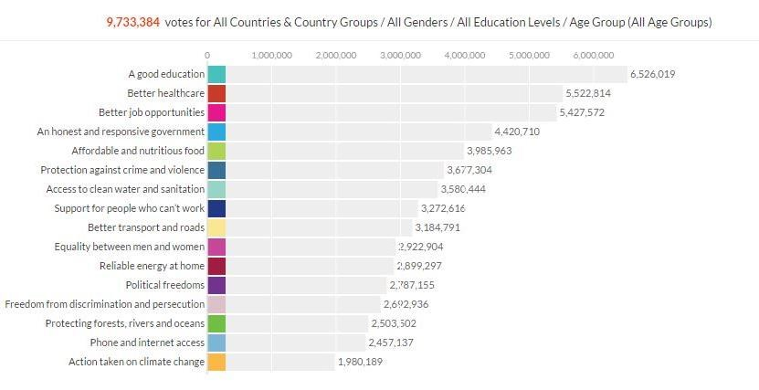
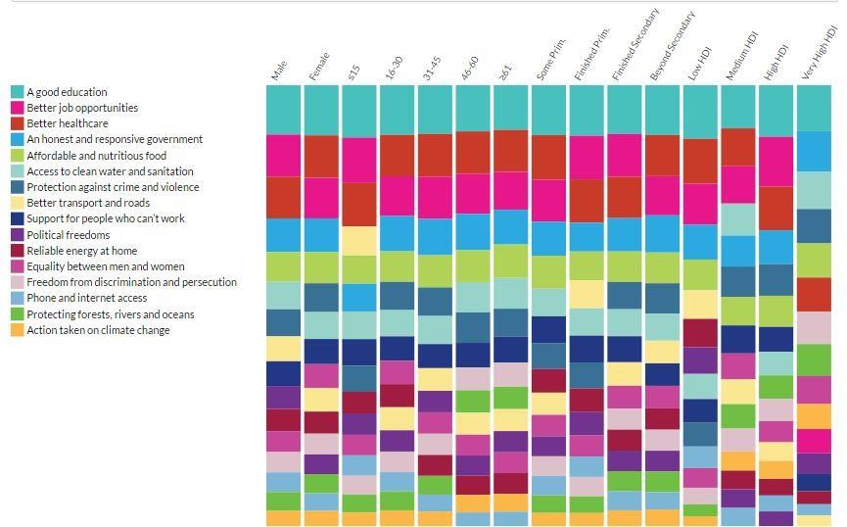
Figure 1. UN My World survey results (Source: United Nations, 2016)

Appendix B – Global South / North

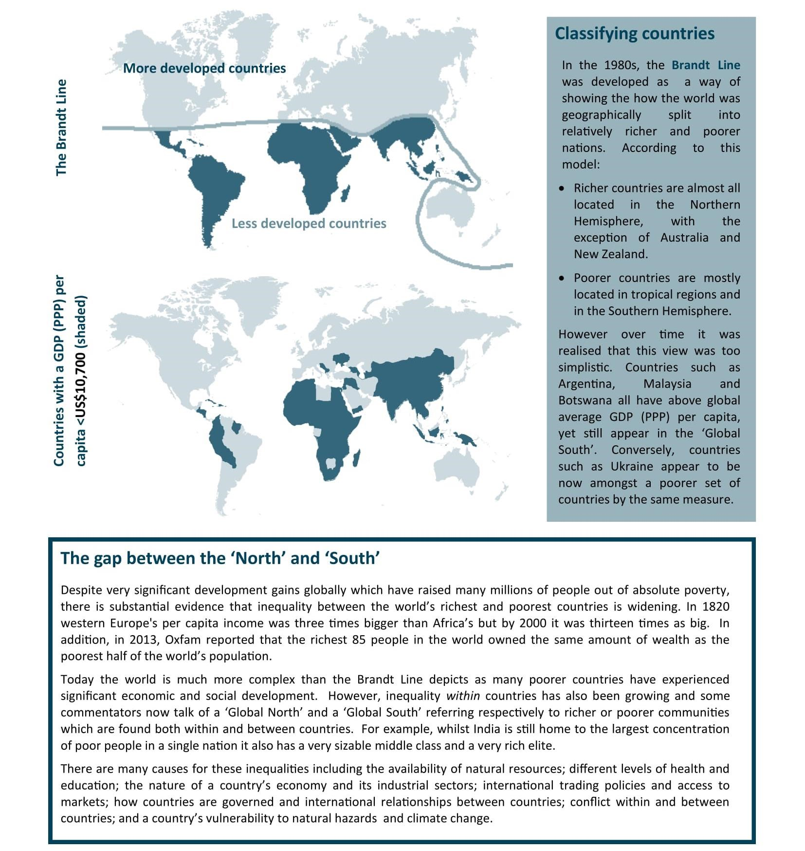
Figure 3. Definition of the Global South/North (Source: Royal Geographical Society, n.d.)

Appendix C Anonymous Company Stakeholder Engagement

Anonymous Company engagement with some of its key stakeholders
The table below is an excerpt from Anonymous Company (2015c) latest sustainability report:

Anonymous Company Material Issues
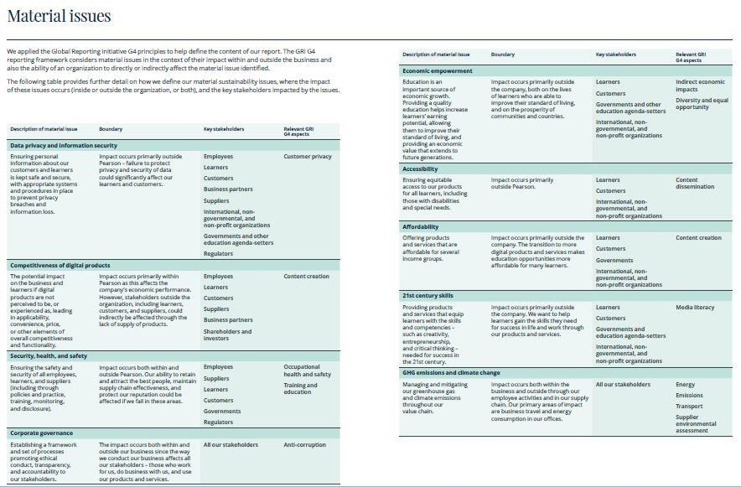
Figure 7.
Anonymous Company Material Issues (Source: Anonymous Company, 2015, pp. 74
-
75)

18

Appendix D Standardized Testing

Overview of Standardized Testing
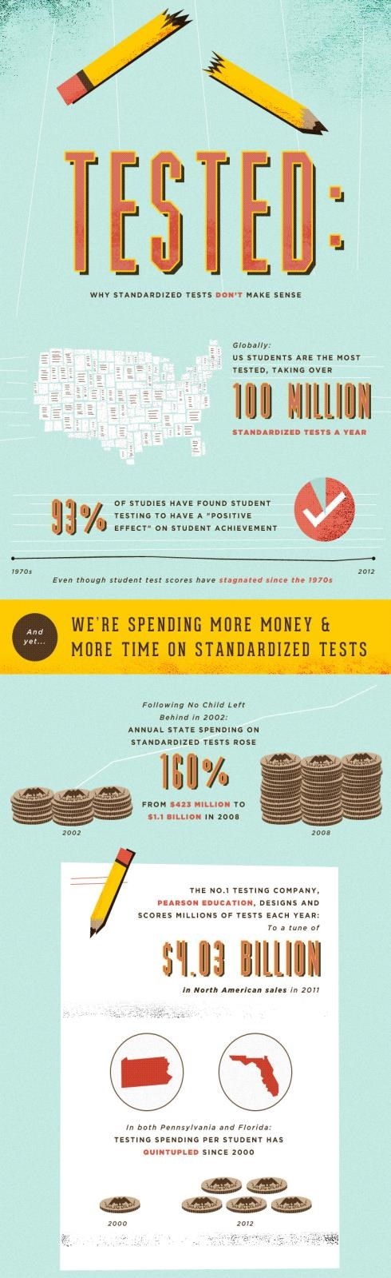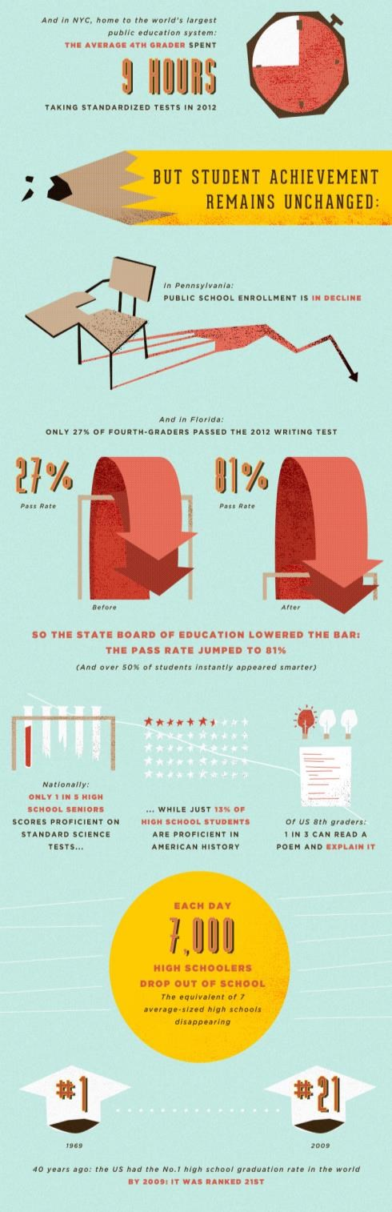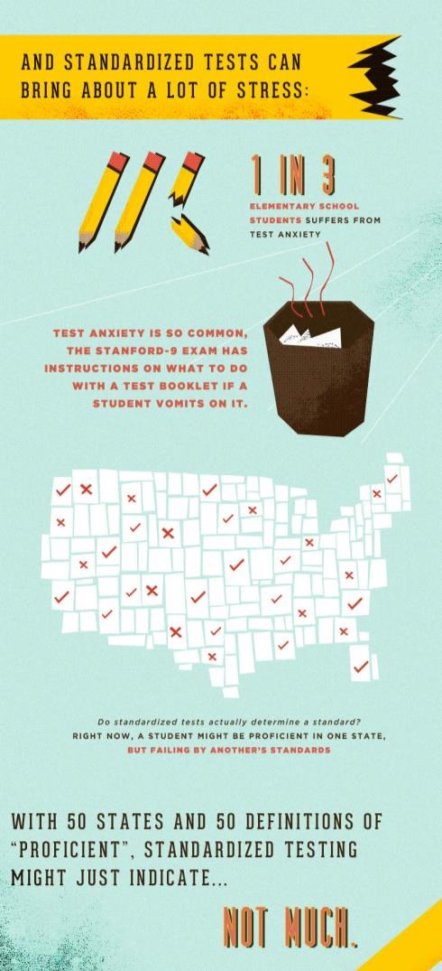
Figure

8
.
Overview of Standardized Testing (Source: Ac
c
redited Online Colleges, n.d.)

19

Cost of Standardized Testing
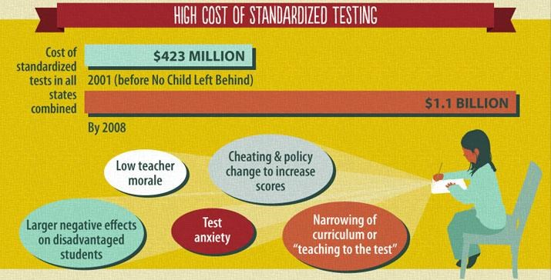
Figure 9.
High
Cost

of Standardized Testing (Source:
Top Education Degrees
, n.d.)

Impact on Educators
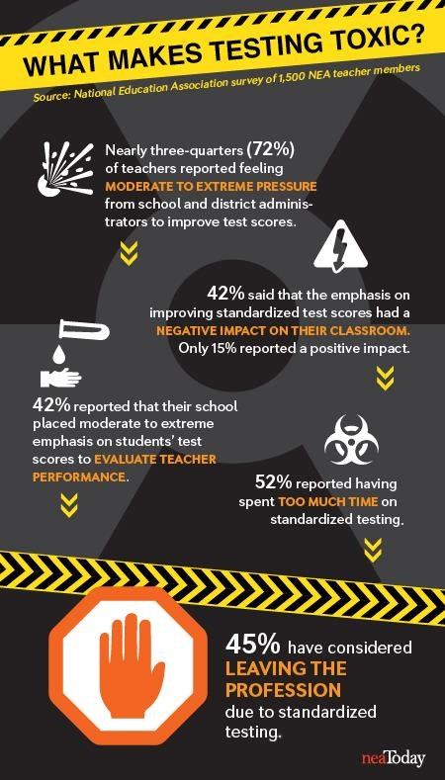
Figure 10. High Cost of Standardized Testing (Source: Walker, 2014)

Appendix E – Anonymous Company SDGs focus

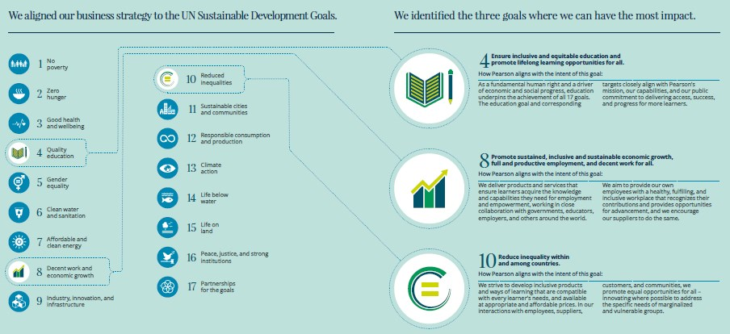
Figure 11.
Anonymous Company and SDGs

(
Source:
Pearson, 2015c
)

21

Appendix F – Education and the SDGs

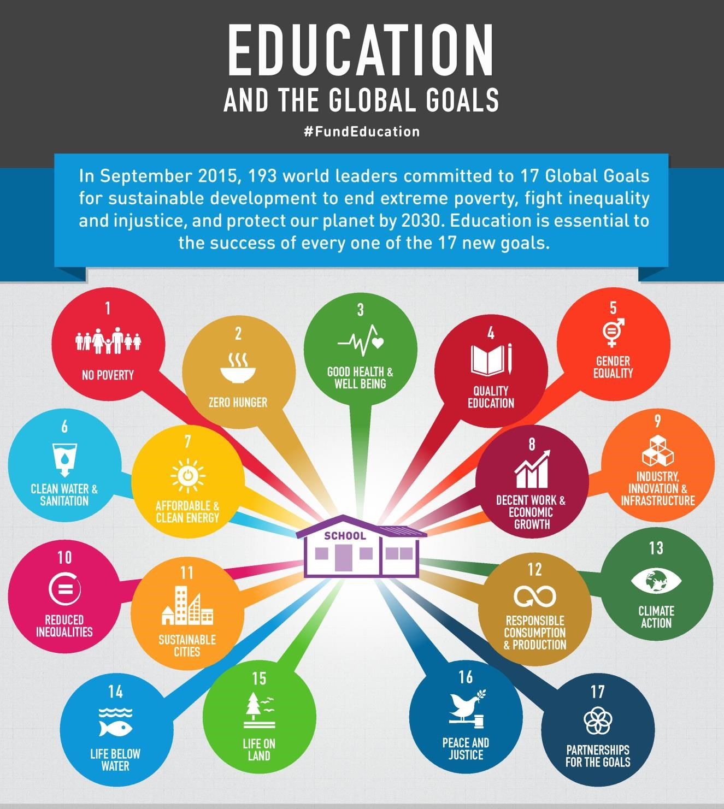

(continued on next page)

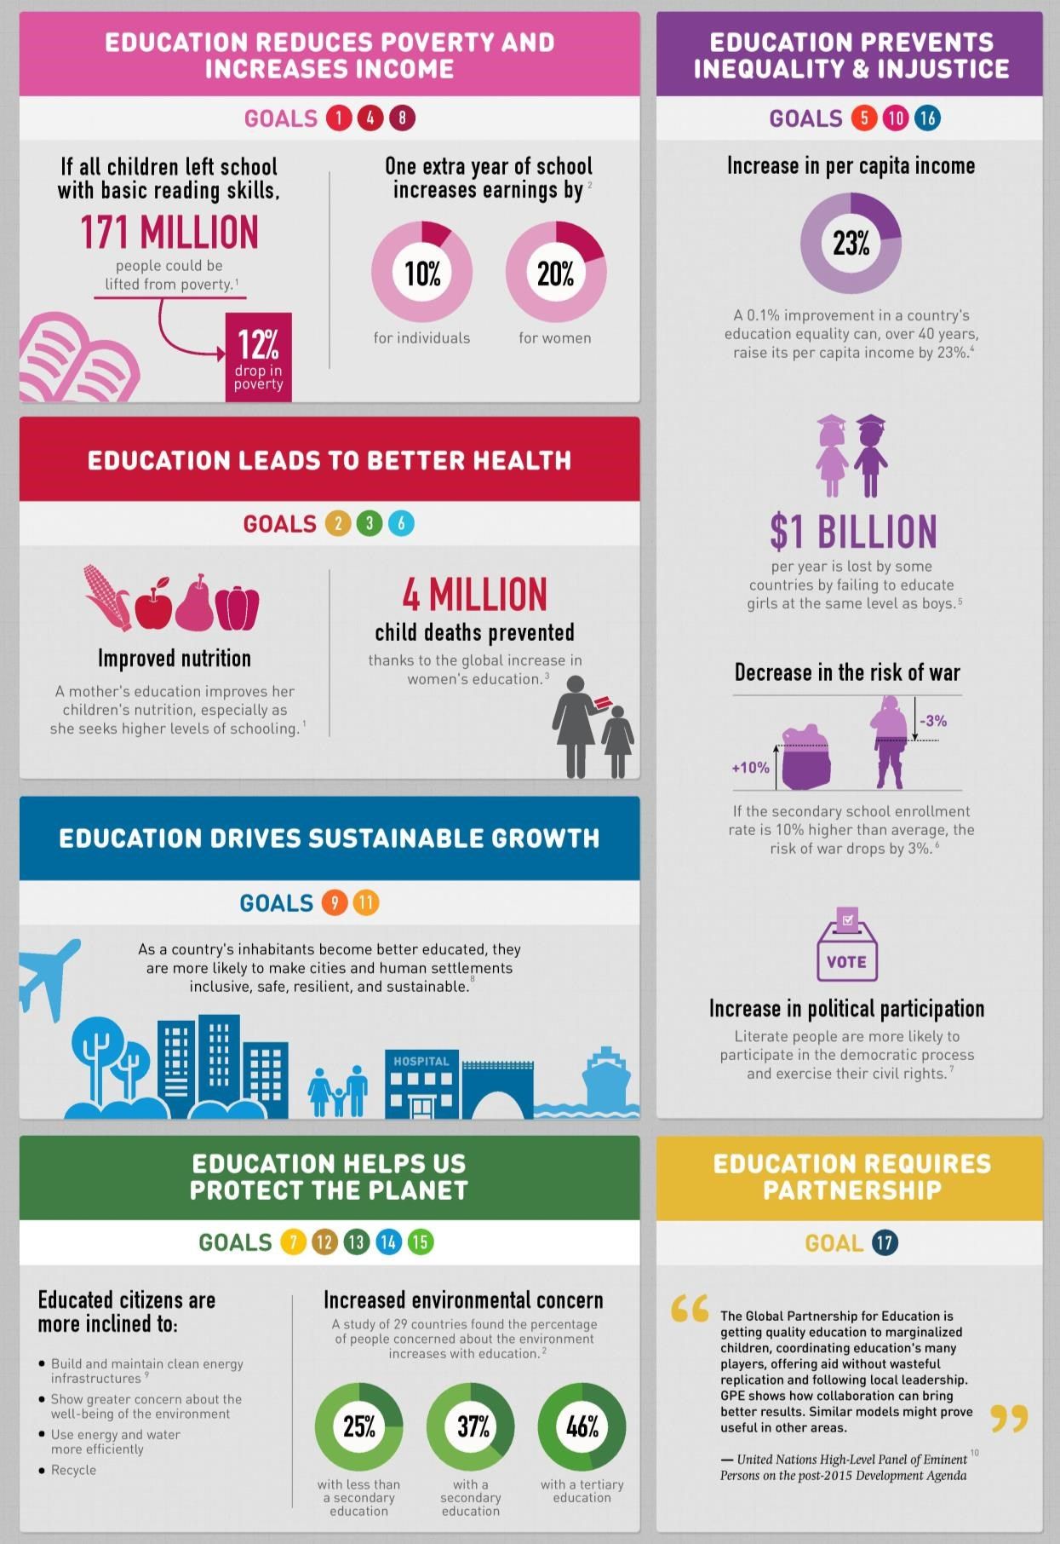

Figure 12
.
Education and the Global Goals

(
Source:
Global Partnership for Education
, 2015
)

Appendix F – Fairness of Standardized Testing
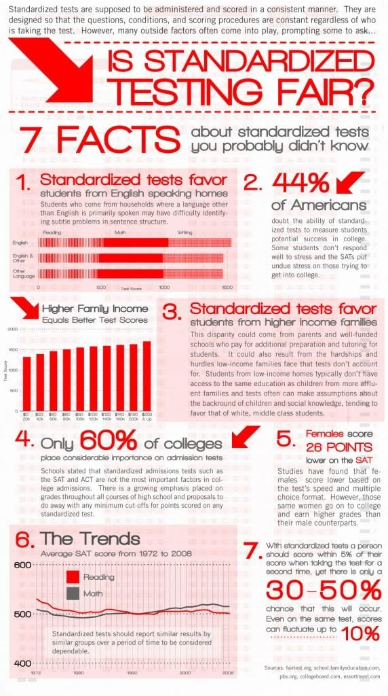

Figure 13. Is standardized testing fair? (Source: Digital Media Diet, 2013)

