Responsible Business and Management Writing Competition 2016/17
Student Name: Helen Mullen (hm372@kent.ac.uk)
Year of Study: 2nd Year
Institution: Kent Business School, University of Kent
Title of Work: “How can Sustainable Management be leveraged for Corporate Social Responsibility?”
Module: CB733-Business Ethics and Sustainability Management
Module Convenor: Dr Adolf Acquaye (a.a.acquaye@kent.ac.uk)

Abstract
The contribution of sustainable management (SM) to corporate social responsibility (CSR) is explored within the context of value-creation across the triple bottom line, with particular focus on environmental and financial stakeholders. Drawing on the natural resource-based view, SM presents a source of competitive advantage by severing the dependence of profit upon natural capital degradation. Various SM tools, practices and frameworks are explored, including life-cycle assessments, supply-chain mapping, sustainable supply-chain management, product design, circular economies, industrial symbiosis, sustainable business models and the sustainability balanced scorecard.
SM is shown to shift the scope of CSR beyond the focal firm to consumers and suppliers, whilst broadening it from short-term to long-term value-creation. Encompassing a wider stakeholder range than traditional CSR, including the natural environment and future generations, SM offers a profitable means of addressing short-falls in meeting these needs. Simultaneously improving economic and environmental performance, SM can help raise CSR standards across company and national boundaries owing to network effects. By incorporating sustainability into its strategic core, a firm will inherently pursue a comprehensive and holistic CSR agenda, as demonstrated by Company A. SM is argued to significantly leverage CSR, however, other factors affect SM’s potency, including leadership, values, governmental support and consumer behaviour.

Essay Title: How can Sustainable Management be leveraged for Corporate Social Responsibility?
This essay addresses the contribution of environmentally-focused sustainable management (SM) to corporate social responsibility (CSR) initiatives. Once defined, these will be rooted in the natural resource-based view and stakeholder theory respectively. An analysis of SM’s effectiveness in meeting environmental and economic societal needs through CSR is presented through examples, exploration of various SM tools and additional factors which play a supporting role. This essay concludes that SM can contribute significantly to CSR by addressing shortfalls in stakeholder identification and environmental impact.
CSR represents the business world’s attempt to discard the notion of profit as its sole-motive by addressing external societal concerns. Carroll defines CSR as “[encompassing] the economic, legal, ethical and [philanthropic] expectations that society has of organisations at a given point in time” (1979, p.500). By incorporating key stakeholder needs into a firm’s strategic processes, CSR can be attributed to Stakeholder Theory, which observes the unethical impact of value-creation and trade upon bodies outwith the firm itself (Freeman et al, 2010). CSR aims to establish or enhance a firm’s ‘triple bottom line’ (TBL): the creation of social, environmental and economic value for the business and its stakeholders (Elkington, 2013). SM shares this objective but seeks attainment by designing, implementing and evaluating activities to meet present needs “without compromising the ability of future generations to meet their own”, (Starik and Kanashiro 2013, Brundtland Commission 1987).
SM is primarily concerned with natural resource management. Resource-dependence theory posits that businesses depend on resources to survive, so resources must be managed to generate power over others with competing demands (Hillman et al, 2009). The Natural Resource-Based view adapted this to include natural resources: as natural capital degrades, competitive and strategic advantages reward firms less dependent on it. Thus, firms practising pollution-prevention, good product stewardship and sustainable development, reap cost-savings, enhanced reputation and knowledge, and secured resource-access (alternative, renewable energy or materials). In gaining these competitive advantages early, SM secures first-mover benefits and the continuous, compounding returns associated with sustainable practice (Hart, 1995). Therefore, TBL value-creation is sustained and regenerative, unlike non-sustainable CSR initiatives which may transfer value from one TBL element to another.
CSR initiatives are implemented in a multitude of ways with varying effectiveness, depending on company resources, capabilities, offerings, industry, values and willingness. A reactive approach may yield ad-hoc, short-term CSR initiatives, where beneficiaries are vulnerable to managerial whims and, particularly when considered more cost than benefit, at times of poor economic performance (Connaway, 2009). Often, social and environmental concerns are addressed by precariously bolting them onto traditional business models under the auspice of CSR (Stubbs and Cocklin, 2008). Where traditional models are primarily driven by financial gain, often through natural capital exploitation, there exists a constraining force on value-creation across the TBL. This ‘afterthought’ approach can produce ineffective initiatives. This is arguably the case with diffuse, strategically-irrelevant philanthropic contributions benefitting stakeholders extraneous to business objectives which, argue Kramer and Porter, fail to generate competitive advantage or effective impact (2002, Laszlo 2013). Conflicting short-term, financially-driven managerial performance and long-term strategic environmental objectives, create value for one stakeholder whilst destroying it for another (Burritt et al 2011). This schizophrenic behaviour is considered more ‘green-washing’ than true CSR, for instance, one global automaker’s philanthropic $25million donation to an environmental centre failed to address its core environmental impact – the production of vehicles heavily reliant on fossil fuels (Engardio et al, 2007). Such PR-induced philanthropy attempts to justify environmentally-destructive practice, offering inferior environmental benefit while depriving shareholders of dividends. SM, however, can avoid these ethical shortfalls and significantly enhance value-creation for owners, environment and society, by incorporating relevant, informed environmental concerns into business strategy.
With a traditionally local focus, stakeholders are typically identified as shareholders, consumers, employees, suppliers, competitors and local community. However, when viewing CSR through the lens of SM, the scope widens. Natural capital provides “fundamental life-support functions”. Thus, as the ‘strong sustainability’ paradigm holds, non-renewable natural capital is non-substitutable: future generations cannot be compensated for natural capital degradation by preceding generations (Neumayer 2010 p.98, Figge and Hahn 2004). Visser argues that in aggregate, CSR has failed to counter or substantially moderate business-induced malaise (2013). This partly owes to an erroneously narrow-view of stakeholders which fails to address wider stakeholder-costs, such as environmental externalities. Alternatively, failure to recognise the true environmental impact may cause CSR initiatives to treat non-renewable natural resources as substitutable.
SM provides the means to address this wider stakeholder group by holistically evaluating a firm’s environmental impact. The Lifecycle Assessment (LCA), for instance, quantifies resources and energy used, emissions and wastes, at every product lifecycle stage. Indicators specify the nature of impact, such as greenhouse gases, acidification, eco-toxicity, eutrophication and ozone-depletion, while resource-depletion is weighted by its relative scarcity, providing a comprehensive assessment of total product impact (Klöpffer, 1997). Assessment extends beyond manufacturing and distribution to include impacts through product consumption, reuse or recycling potential and disposal (Stead and Stead, 2009). As product design largely determines life-long environmental impact, LCAs can inform optimal design for minimal ecological damage (Waage, 2007).
Hybrid LCAs assess impacts across complex, local and global supply-chains, including direct and indirect impacts, improving data accuracy. These data partially inform supply-chain mapping to expose high-emission or resource-intensive hotspots and clarify material-flows. Hotspots can then be modified to improve eco-efficiency, (Acquaye et al 2014, Figge and Hahn 2004). Such tools enable system-wide benchmarking across the supply-chain, product lifecycle and industry, to compare eco-efficiency measures against previous performance, competitors and alternative product designs. This informs where investments will maximise environmental returns and enables continuous eco-efficiency improvements which afford competitive advantages, providing sustained and compounded value-creation for environmental and financial stakeholders (Acquaye et al, 2014). One study observed how a paper mill deserted plans to green end-of-pipe technology following an assessment using SM tools, which revealed logistical modifications earlier in the supply-chain would cost less and reduce emissions tenfold (Baumann, 2013).
Once ascertained, the supply-chain’s environmental impacts could be addressed through sustainable supply-chain management (SSCM). SSCM uses systematic coordination to minimise environmental degradation across a product’s entire production process. This generates long-term value contributions to TBLs across the chain, through reduced risk of natural resource depletion and costs associated with rising energy prices, regulatory introductions or breaches (Carter and Rogers 2008, Genovese et al 2015). SSCM could include reducing virgin-material inputs, reusing waste materials (circular economy), product recovery and reuse, increasing output quality for durability and fewer rejects, cleaner production processes and more besides (Bocken et al 2014, Stead and Stead 2009). Whereas CSR initiatives may reduce environmental impact for a focal firm, SSCM yields significant, additional reductions by addressing the supply-chain’s environmental impacts (Lake et al, 2014).
SSCM relies on collaboration between the focal and supply-chain firms (Acquaye et al, 2014). Sharing information, research and capital resources with suppliers drives resource-efficiencies through technological advancements (knowledge), and affords them to suppliers without sufficient capital to achieve alone. Rowley noted stakeholders are connected by a network, rather than dyadic ties (1997). Thus, as suppliers adopt more sustainable capabilities, this captures a wider stakeholder range: those of the focal firm and their suppliers, essentially creating value along numerous interconnected, networked stakeholder groups, potentially with global reach. Higher supply-chain visibility afforded by SM tools and SSCM could expose suppliers with illicit practices, ensuring the focal firm’s legal compliance despite international legislative differences (Carter and Rogers, 2008). Non-conforming suppliers may be motivated and supported to improve practice, enhancing environmental performance and, potentially, standards across national boundaries (Appendix 2).
Data harvested using SM tools supports transparent corporate behaviour through realistic environmental impact estimates. Sustainability reporting communicates the effects of corporate behaviour and how it is being addressed. To take responsibility, firms must be held accountable so stakeholders can assess behaviour and challenge where necessary (Doane, 2004). These tools, propose Gray and Milne, shift CSR from “rhetoric and ignorance” to “practice and transparency” (2004, p.76). In 2002, one multinational fast-food chain boasted its environmental achievement of reduced water-consumption in its restaurants. Within context however, this virtue was overwhelmingly overshadowed by the 600 gallons of water required to produce one of its notorious quarter-pounders. While this rhetoric may have generated profit through improved reputation and some reduced costs, it ignored its true environmental costs of water consumption (Gray and Milne, 2004). Limited information and selective disclosure meant these impacts remained unchallenged and belied this multinational’s unbalanced, ineffective contribution to its TBL.
By contrast, one smartphone manufacturer has incorporated SM to create significant TBL returns compared to standard smartphone manufacturers. Company A’s durable, modular design, enables users to remove and replace certain parts for upgrade or repair. This extends product life to three years, compared to two years for standard smartphones (Company A 2015, 2016). Using LCAs, Company A compared the environmental performance of alternative product designs. Currently, its business model is based on a long-lasting product which can be reused and recycled to reduce metal reserve-depletion and carbon emissions. Life-cycle could extend to six years by introducing a repair service and refurbishing ‘end-of-life’ components, reducing metal consumption by 35%. However, calculations show a circular model could facilitate a 53% reduction (Güvendik, 2014) (Appendix 3).
Unlike a traditional linear model of material-flow through a supply-chain, where resources are constantly depleted and emissions created, a circular model is characterised by looped material-flows. Here, SM mimics nature’s self-sustaining generation, use and reuse of organic resources. Thus, the circular economy aims to regenerate value using existing resources (Genovese et al 2015, Stead and Stead 2009). This represents a departure from the traditional model by “decoupling (...) economic value from resource input and pollution” (Neumayer, 2010 p.80). Company A may further this departure through a closed-loop supply-chain, switching from a product-sales to leasing-service model, substituting ownership for functionality (Appendix 4).
Retaining ownership and responsibility of its smartphones means this company reclaims and dismantles the end-of-life product, so components can be refurbished and reused for new smartphones, and materials recycled for secondary markets. Industrial symbiosis sees waste materials become inputs into other supply-chains, for instance, using camera components to manufacture medical tools (Güvendik 2014, Bocken et al, 2014). This open-loop approach, along with the closed-loop supply-chain promotes “self-sustaining production” through repeated material use and value-recovery (Genovese et al, 2015 p.355). In open-loop supply-chains, value is created accumulatively across the wider stakeholder network, independently of virgin resources, bolstering the TBL through cost-savings and reduced environmental impact.
By embedding sustainability into its business model, Company A has balanced environmental, financial and social stakeholder needs, including intergenerational stakeholders. Using SM tools, it has ascertained long- and short-term stakeholder-costs and internalised them through innovative product design, value-proposition and production methods, to create value more equitably across the TBL (Stead and Stead, Laszlo 2013). Assessing current and potential TBL contributions of alternative production process and product designs supports a business case by presenting cost- and risk-reductions, innovative capability developments, profitability or brand value (Schaltegger et al, 2011). This provides the means to incorporate eco-efficiency objectives into business strategy, using the Sustainability Balanced Scorecard - a tool vital for aligning long-term eco-efficiency and short-term managerial performance (Figge et al, 2002). In this instance, SM tools are used to create an effective sustainable business model, bringing environmental and social stakeholder priorities to the business core.
SM makes meeting society’s economic needs achievable without compromising stakeholders through unaddressed externalities. Sustainability accounting tools assess long-term value rather than short-term cost, shifting the corporate mind-set from solely avoiding costly consequences, to pursuing new profitable opportunities (Stead and Stead 2009). Increased collaboration with stakeholders identifies better ways to meet society’s needs, and in the case of SSCM, creates vertical integration to better control natural resources, yielding competitive advantage and “economic sustainability” (Carter and Rogers, 2008 p.374).
Carroll provides five components required to meet society’s economic expectations, including consistently maximising share earnings and profitability, maintaining highly efficient operations and strong competitiveness (1991). Thus, CSR is predicated on the assumption that financial performance can improve with environmental performance. The revisionist perspective holds environmental performance can be profitable to an optimum point, beyond which environmental improvements result in financial decline (Abdelkafi and Täuscher, 2015). This could plausibly owe to the law of diminishing returns, where initial CSR-inspired gains are easily achieved through inexpensive efficiency measures before necessitating costly, alternative technology or operations for progression (Hart, 1995). Sustainable business, however, seeks to shift the optimum point outward through value-creation opportunities, affording higher levels of financial and environmental returns (Wagner and Schaltegger, 2003) (Appendix 5).
The higher the environmental returns, the more a firm can meet society’s ethical expectations. Ethical CSR practice can become customary or legally mandated over time (Martin, 2003). Przychodenzen holds that ‘basic CSR’ focuses on legal compliance, while sustainable CSR often exceeds legal requirements, which arguably then meets society’s ethical expectations (2014). Legal compliance may mitigate the risk of fines or reputational-damage to some degree. However, use of sustainability accounting tools, indicators and designs can showcase desirable and achievable standards. As law and regulation are society’s codified ethics, these tools could raise minimum legal requirements (Carroll 2016, Przychodzen 2016). Lyon and Maxwell contend that some companies deflect stricter regulation through incremental environmental performance prior to potential codification (unsustainable CSR). Such ineffective regulatory practice could be mitigated if regulators use data provided by truly sustainable companies, to set the standards in a given industry. Enhanced environmental regulations benefit stakeholders of firms practising basic CSR, including the shared stakeholders of sustainable firms – the environment and future generations. The European’s Commission ‘Roadmap to a Resource Efficient Europe’ is testimony to the use of SM tools to inform legislation, citing the use of LCA, eco-design, eco-labelling, circular economies and industrial symbiosis among others (2011) (Appendix 6).
While SM may raise ethical and legal standards, there are limitations on its ability to leverage CSR, which are partly dictated by business values. Defensively adopting accounting tools through compliance means the data produced may not be put to good use, for instance through SSCM or product redesigns. It may even lead to misuse of SM tools: the LCA is difficult in application and subjective in interpretation – a weakness that can be exploited to obscure unfavourable environmental impacts. Accommodative firms may use tools to address a few environmental concerns; while providing some eco-efficiencies, this falls short of realising maximum returns or fully balancing environmental stakeholder needs. However, when SM tools are combined with sustainability as a core value, CSR is maximised, potentially generating a net-benefit in environmental impact. To illustrate, the accommodative firm may use SM to improve eco-efficiency in line with competitors, but then express this competitive advantage through price-competition, causing higher absolute consumption of natural resources (Appendix 7). A proactive firm with sustainability embedded in its business model, would seek to negate this rebound effect by actively influencing consumer behaviour and adopting an innovative business model to maximise environmental performance (Figge and Hahn 2004, Bocken et al, 2014).
Without visionary leadership, inspired by good moral imagination to include wider stakeholder perspectives and innovative business models, the benefits of SM cannot prevail over the short-term implementation costs (Redekop, 2013). Core values must encapsulate environmental needs to shape a business culture dedicated to sustainable practice. Overhauling business processes and product designs, or attempting new, untried business models can be risky and costly in the short-term compared to non-sustainable CSR initiatives. Furthermore, willing collaborators (including competitors) are essential to generating knowledge and capabilities, and pooling resources (Sourabh 2011, Stubbs and Cocklin 2008). Those without the right leadership, vision and values may be unable and unwilling to see beyond initial barriers, to contemplate the long-term returns to the TBL.
Overcoming prohibitive costs of penetrating standardised markets or sustainable redesigns may necessitate external support, such as government subsidies (Genovese et al, 2015). Additionally, upgrading sustainability guidelines can ensure more meaningful, sustainable contributions: the voluntary standard for environmental management, ISO14001, for instance, addresses eco-efficiency but not absolute natural capital degradation limits (Visser, 2013). Changing consumer behaviour to reduce absolute consumption and accept new value-propositions (such as leasing functionality rather than product ownership), requires educational engagement at organisational and societal levels, to drive understanding about the interconnectedness of individual choices, commercial activity and the environment (Stubbs and Cocklin 2008, Starik and Kanashiro 2013) (Appendix 8).
Ultimately, SM leverages CSR by more adequately encompassing and integrating key stakeholder needs into business practice and value-creation. Through accounting and indicator tools, firms achieve better understanding of the nature, extent and sources of their environmental impacts. Misidentification and inaccurate stakeholder-costs assessment limits the ability of CSR initiatives to address them, thus traditional CSR offers only incremental and arguably inadequate improvements. By contrast, more informed firms can redesign products, processes and supply-chains, significantly reducing environmental impact beyond their boundaries, into the realms of their supply-chain organisations, external supply-chains and industries, consumer use and disposal. These tools support innovative approaches to business, inspiring new business models, alternative products and manufacturing processes, centred on severing the dependence of economic value on natural capital degradation. Consequently, SM provides the opportunity to preserve the life-quality of future generations and the current natural environment, automatically adopting these as stakeholders in a way traditional CSR has not. This exemplifies how SM more accurately balances stakeholder-costs and value-creation over the short- and long-term, making a more meaningful and enduring contribution to CSR.
SM could improve mandated industrial standards by showcasing the ability to profit whilst addressing environmental externalities, and indicating environmental impact across an industry. Essentially, this indirectly creates value for the environmental stakeholder and raises corporate ethical standards. However, SM’s ability to leverage CSR depends on the willingness and intent behind a firm’s implementation, providing maximal effect when sustainability values are at the business core. Eco-efficiency results only through effective use of SM tools – an outcome potentially hampered by dishonest use or poor application. Potentially, robust governmental support and consumer education could mitigate disingenuous use. Effective SM can leverage human capital and combine resources through stakeholder collaboration, generating competitive advantage and enabling financial gains through value-creation, risk- and cost-reductions. Over time, shareholders benefit while profits sustain the firm’s on-going contributions to CSR initiatives. In generating continuous eco-efficiencies and value-creation opportunities, SM can deliver significant and compounding TBL contributions compared to traditional CSR.

References:
Abdelkafi, N. and Täuscher, K. (2015). Business models for sustainability from a system dynamics perspective. Organization & Environment, 1–23.
Acquaye, A., Genovese, A., Barrett, J. and Koh, S. C. L. (2014). Benchmarking carbon emissions performance in supply chains. Supply Chain Management: An International Journal, 19(3), 306–321.
Baumann, H. (2013). Life Cycle Assessments (LCAS). In: Laszlo, C. ed. Business Strategies and Management for Sustainability. Great Barrington, USA: Berkshire Publishing Group LLC, pp. 59–64.
Bocken, N. M. P ., Short, S. W ., Rana, P . and Evans, S. (2014). A literature and practice review to develop sustainable business model archetypes. Journal of Cleaner Production, 65, 42–56.
Brundtland Commission (1987). Report of the World Commission on Environment and Development: Our Common Future. [Online]. UN Documents. Available from: http://www.un-documents.net/our-common-future.pdf [Accessed 13 December 2016].
Burritt, R. L., Schaltegger, S. and Zvezdov, D. (2011). Carbon management accounting: Explaining practice in leading German companies. Australian Accounting Review, 21(1), 80–98.
Carroll, A. B. (1979). A Three-Dimensional conceptual model of corporate performance. The Academy of Management Review, 4(4), 497–505.
Carroll, A. B. (1991). The pyramid of corporate social responsibility: Toward the moral management of organizational stakeholders. Business Horizons, 34(4), 39–48.
Carroll, A. B. (2016). Carroll’s Pyramid of CSR: Taking Another Look. International Journal of Corporate Social Responsibility, 1(1).
Carter, C. R. and Rogers, D. S. (2008). A framework of sustainable supply chain management: Moving toward new theory. International Journal of Physical Distribution & Logistics Management, 38(5), 360–387.
Company A (2015). Examining the Fairphone’s environmental impact [Online]. Fairphone. Available from: https://www.fairphone.com/en/2015/01/22/first-fairphones-environmental-impact/ [Accessed 8 December 2016].
Company A (2016). Fairphone spare parts [Online]. Fairphone. Available from: https://shop.fairphone.com/en/spare-parts [Accessed 10 December 2016].
Doane, D. (2004). Good Intentions - Bad Outcomes? The Broken Promise of CSR Reporting. In: Henriques, A. and Richardson, J. eds. The triple bottom line, does it all add up? Assessing the sustainability of business and CSR. London: Earthscan Publications, pp. 81–88.
Elkington, J. (2013). Triple Bottom Line. In: Laszlo, C. ed. Business Strategies and Management for Sustainability. Great Barrington, USA: Berkshire Publishing Group, pp. 121–124.
Engardio, P., Capell, K., Carey, J. and Hall, K. (2007). Beyond The Green Corporation; Imagine a world in which eco-friendly and socially responsible practices actually help a company’s bottom line. It’s closer than you think. Business Week.
European Commission (2011). Roadmap to a Resource Efficient Europe. Brussels: European Commission.
Figge, F. and Hahn, T. (2004). Sustainable Value Added—measuring corporate contributions to sustainability beyond eco-efficiency. Ecological Economics, 48(2), 173–187.
Figge, F., Hahn, T., Schaltegger, S. and Wagner, M. (2002). The sustainability balanced scorecard - linking sustainability management to business strategy. Business Strategy and the Environment, 11(5), 269–284.
Freeman, E. R., Harrison, J. S., Wicks, A. C., Parmar, B. L. and de Colle, S. (2010). Stakeholder theory: The state of the art. Cambridge: Cambridge University Press.
Genovese, A., Acquaye, A. A., Figueroa, A. and Koh, S. C. L. (2015). Sustainable supply chain management and the transition towards a circular economy: Evidence and some applications. Omega, 66, 344–357.
Gray, R. and Milne, M. (2004). Towards Reporting on the Triple Bottom Line: Mirages, Methods and Myths. In: Henriques, A. and Richardson, J. eds. The Triple Bottom Line: Does It All Add Up? London: Earthscan Publications, pp. 70–80.
Güvendik, M. (2014). From Smartphone to Futurephone: Assessing the Environmental Impacts of Different Circular Economy Scenarios of a Smartphone Using LCA.
Güvendik, M. (2015). Examining the Fairphone’s Environmental Impact’ [Online]. Fairphone. Available from: https://www.fairphone.com/en/2015/01/22/first-fairphones-environmental-impact/ [Accessed 14 December 2016].
Hart, S. L. (1995). A natural-resource-based view of the firm. The Academy of Management Review, 20(4), 986–1014.
Hillman, A. J., Withers, M. C. and Collins, B. J. (2009). Resource dependence theory: A review. Journal of Management, 35(6), 1404–1427.
Klöpffer, W. (1997). Life Cycle Assessment: From the Beginning to the Current State. Enviornmental Science and Pollution Research, 4(4), 223–228.
Lake, A., Acquaye, A., Genovese, A., Kumar, N. and Koh, S. C. L. (2014). An application of hybrid life cycle assessment as a decision support framework for green supply chains. International Journal of Production Research, 1–27.
Laszlo, C. (2013). Sustainable Value Creation. In: Laszlo, C. ed. Business strategies and management for sustainability. Great Barrington, USA: Berkshire Publishing Group LLC, pp. 112–117.
Martin, R. L. (2003). The Virtue Matrix: Calculating the Return on Corporate Responsibility. Harvard business review on corporate responsibility. Boston, MA: Harvard Business School Pub. Corp., pp. 83–103.
Neumayer, E. (2010). Weak versus strong sustainability: Exploring the limits of two opposing paradigms. 3rd edn. Cheltenham, UK: Edward Elgar Publishing.
Porter, M. E. and Kramer, M. R. (2003). The Competitive Advantage of Corporate Philanthropy. Harvard Business Review on Corporate Responsibility. Boston, MA: Harvard Business School Publishing Corporation, pp. 27–64.
Przychodzeń, W. and Przychodzeń, J. (2014). Corporate social responsibility for sustainability. Management and Business Administration. Central Europe, 22(2), 80–97.
Rebitzer, G., Ekvall, T., Frischknecht, R., Hunkler, D., Norris, G., Rydberg, T., Schmidt, W. P., Suh, S., Weidema, B. P. and Pennington, D. W. (2004). Lifecycle assessment. Part 1: Framework, goal and scope definition, inventory analysis and applications. Environment International, 30, 701–720.
Redekop, B. W. (2013). Leadership. In: Laszlo, C. ed. Business Strategies and Management for Sustainability. Great Barrington, USA: Berkshire Publishing Group LLC, pp. 53–57.
Rowley, T. J. (1997). Moving beyond Dyadic ties: A network theory of Stakeholder influences. The Academy of Management Review, 22(4), 887– 910.
Schaltegger, S., Lüdeke-Freund, F. and Hansen, E. G. (2011). Business Cases for Sustainability and the Role of Business Model Innovation: Developing a Conceptual Framework. Lueneburg: Leuphana University of Lueneburg.
Sourabh, A. (2011). Business Models for Modular Carpet Tile Recycling in India: A project in collaboration with InterfaceFLOR. [Online]. London: Imperial College London. Available from: https://workspace.imperial.ac.uk/environmentalpolicy/Public/Executive%20Su mmaries%202010-2011/B_and_e/Sourabh,%20Animesh.pdf [Accessed 12 December 2016].
Starik, M. and Kanashiro, P. (2013). Toward a theory of sustainability management: Uncovering and integrating the nearly obvious. Organization & Environment, 26(1), 7–30.
Stead, J. G. and Stead, W. E. (2009). Management for a Small Planet. 3rd edition edn. New York: M.E. Sharpe Inc.
Stubbs, W. and Cocklin, C. (2008). Conceptualizing a ‘sustainability business model’. Organization & Environment, 21(2), 103–127.
Visser, W. (2013). CSR and CSR 2.0. In: Laszlo, C. ed. Business Strategies and Management for Sustainability. Great Barrington, USA: Berkshire Publishing Group, pp. 17–21.
Waage, S. A. (2007). Re-considering product design: A practical ‘road-map’ for integration of sustainability issues. Journal of Cleaner Production, 15(7), 638–649.
Wagner, M. and Schaltegger, S. (2003). Introduction: How does sustainability performance relate to business competitiveness? Greener Management International, (44), 5–16.
Appendices:
- Assignment Brief
- Sustainable Pathway Framework
- Company A – Sustainable Design and Business Model Options
- Company A – Circular Economy
- Revisionist View of Relationship Between Economic and Environmental Performance
- Lifecycle Assessment Framework and Applications
- Rebound Effect
- Systems-based Model of Sustainable Business

APPENDIX 1: Assignment Brief
CB733: Business Ethics and Sustainability Management Assignment II: Essay
Essay Topic:
‘How can Sustainable Management be leveraged for Corporate Social Responsibility?’
Context:
Sustainability Management and Corporate Social Responsibility are two constructs related to responsible business management and practice as both shares a common objective of seeking to meet the Triple Bottom Line objectives in business and society. However, there is an increasing difficulty in the understanding of each concept, its implications, and its relation to each other in terms of differences and similarities (Schwartz and Carroll, 2007).
In terms of definitions, the literature is littered with varied interpretations of what are Corporate Social Responsibility and Sustainability Management. It is however generally accepted that Corporate Social Responsibility or CSR involves the attempt by companies to meet the economic, legal, ethical, and philanthropic demands of a given society at a particular point in time (Carroll, 1999). In terms of Sustainability Management (referred to as Corporate Sustainability at the organisational level of analysis), this generally refers to the formulation, implementation and evaluation of sustainability-related decisions and actions (Starik and Kanashiro, 2013).
Given these potential conflicts in the understanding and application of the two concepts (Montiel, 2008), your essay is to be developed specifically within the following contexts. The contemporary view of CSR is that it is strongly associated with the stakeholder theory and so it involves businesses identifying its stakeholder groups and incorporating their needs and values within the strategic and day-to-day decision-making process. The context of Sustainability Management on the other hand should focus on the natural resource-based view which states that organization depends on resources, which are usually required to fulfil its purposes and goals and so an organisation’s Sustainability Management programme will seek to manage these resources use and organisational environmental impacts in a sustainable way.
Given these context, you are to write an essay describing how some of the many varied actions that can adopted in a Sustainable Management programme be leveraged in order to enhance the elements of CSR; that is: economic, legal, ethical, and philanthropic demands.
Expected Output:
A 3000 maximum word essay. Anything beyond +10% of this will be penalised.
Your work should draw from different sustainability management concepts some of which may have been covered in the module.
Specific examples of such concepts to support your arguments will be a plus. Marks for Assignment II
Assignment I will account for 30% of the total for the module.
Due Date and Venue:
The deadline for Moodle submission of the soft copy of the slides is Thursday 15 December 2016 at 5pm.
- A hard copy of the essay should be handed in to the Students’ Office by the deadline.
- A soft copy should also be submitted on Moodle. Additional Instructions:
- Your Seminar Group Number should be clearly stated on the cover sheet.
- A soft copy should be submitted on Moodle using your Seminar Group Link.
- All essays will be checked against Turnitin so ensure your work is appropriately cited to avoid plagiarism.
- References Carroll, A. B. (1999) Corporate social responsibility evolution of a definitional construct. Business & Society 38(3):268-295. Montiel, I. (2008) Corporate social responsibility and corporate sustainability separate pasts, common futures. Organization & Environment 21(3):245-269. Schwartz, M. S. & Carroll, A. B. (2007) Integrating and unifying competing and complementary frameworks: The search for a common core in the business and society field. Business & Society. Starik, M. & Kanashiro, P. (2013) Toward a theory of sustainability management: Uncovering and integrating the nearly obvious. Organization & Environment:1086026612474958.
- APPENDIX 2: Sustainable Pathway Framework
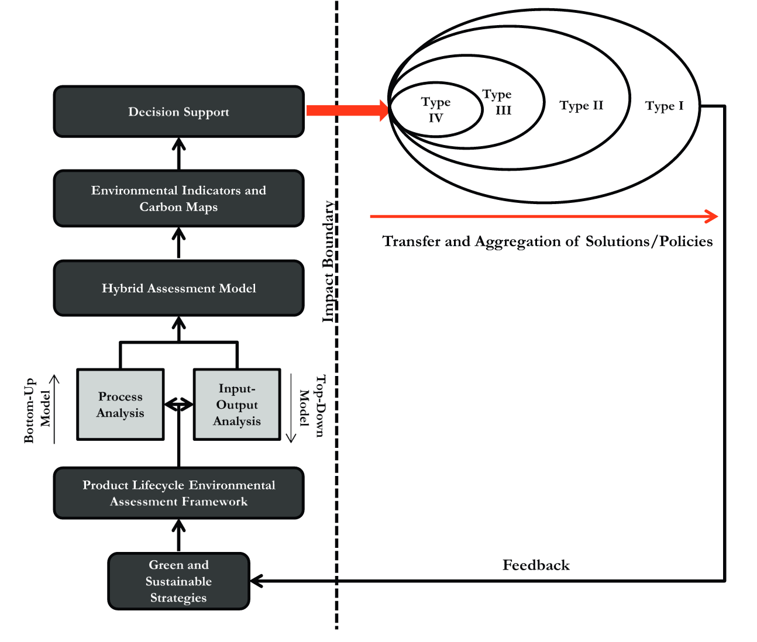Illustration of a bottom-up sustainable pathway framework – taken from Genovese et al, 2015 p.355
Type I: Earth; Type II: Regions/Cities; Type III: Businesses; Type IV: Sustainable technologies or product level
Demonstrates ability of sustainability management tools, including the hybrid lifecycle assessment and supply-chain mapping, to inform environmental impact and subsequent decision-making (for instance product, production and supply-chain design). This illustration also indicates that the different systems outwith the organisation, indicating that product-level analysis (LCA) can be used to assess total impact at each system level. Feedback from which can inform further product-level improvements in environmental performance by the focal company, or through subsequent informed policy enforced at different systems-levels.

APPENDIX 3: Company A – Sustainable Design and Business Model Options
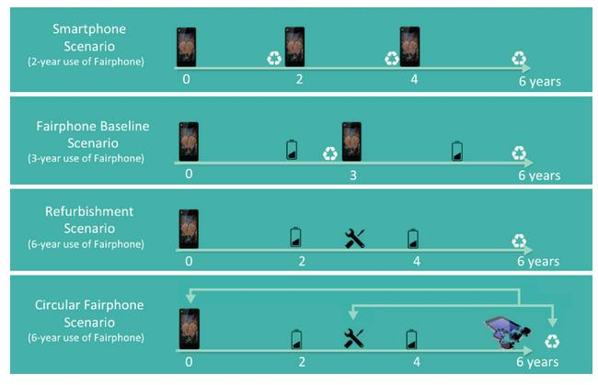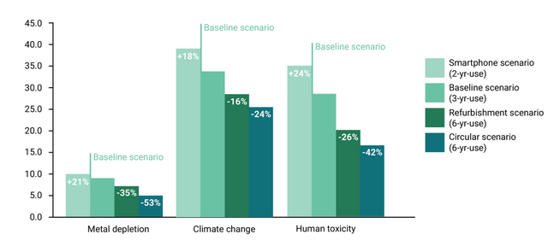
Illustration of sustainable design and manufacturing options for Company A’s smartphone and the respective eco-efficiency achieved – taken from Güvendik, 2015
The Baseline Scenario represents the current model, while the Circular Scenario represents Company A’s ideal model, requiring business model adjustments and facility investments. Environmental performance was assessed using Lifecycle Assessments.

APPENDIX 4: Company A – Circular Economy
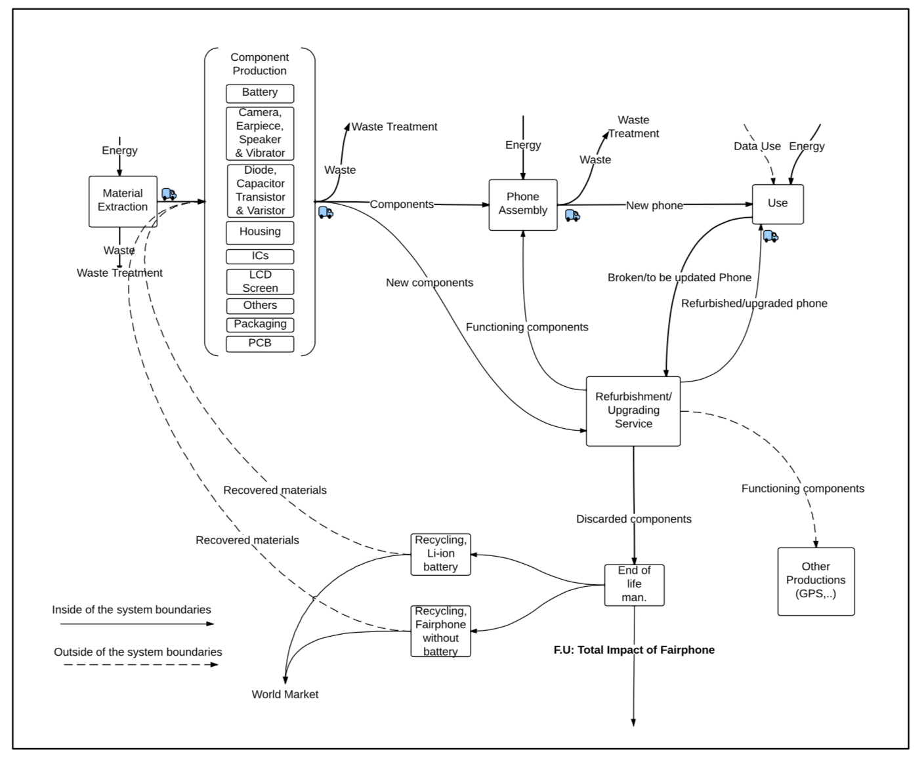
Company A - The new circular economy system for scenario 4 – taken from Güvendik 2014
Wastes are largely treated to reduce toxicity or recycled. Material inputs comprise some virgin materials and energy, externally recovered materials, and refurbished components. Some components are used for other, external productions (industrial symbiosis).

APPENDIX 5: Revisionist View of Relationship between Economic and Environmental Performance
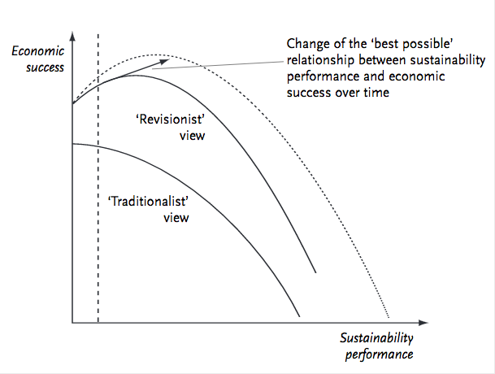
Illustration of the Traditional and Revisionist views of the relationship between environmental and social performance and economic success – taken from Schaltegger and Wagner, 2003 p.44
Based on the revisionist view curve, a sustainable business model seeks to shift the optimum point outwards to secure increasing economic and environmental returns.

APPENDIX 6: Lifecycle Assessment Framework and Applications
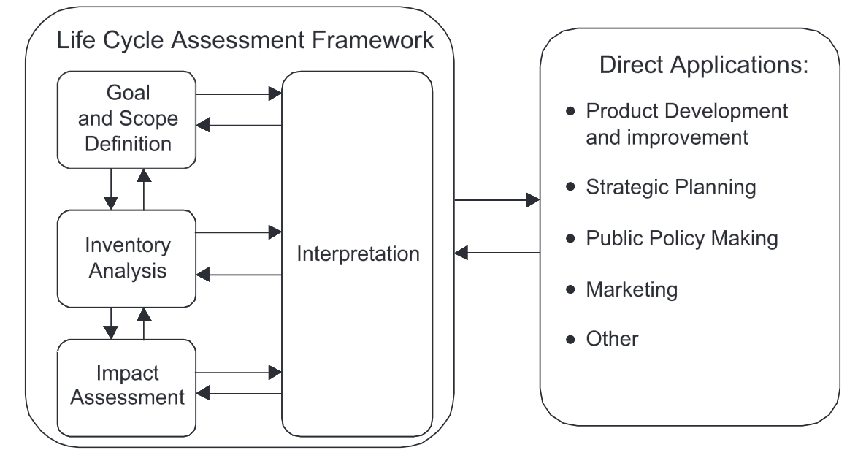
Lifecycle Assessment Framework and applications of its use – taken from ‘Life cycle assessment. Part 1: Framework, goal and scope definition, inventory analysis and applications’, (Rebitzer et al, 2004 p.704)
Product development and improvement includes identifying production hotspots to target and inform product design.
Strategic planning can include long-term changes to product offering or production methods (including sustainable supply chain management).
Public policy making includes informing regulatory bodies of achievable, sustainable standards within a given industry – such as legislation to be implemented by the European Commission’s Roadmap to Resource Efficient Europe.
APPENDIX 7: Rebound Effect
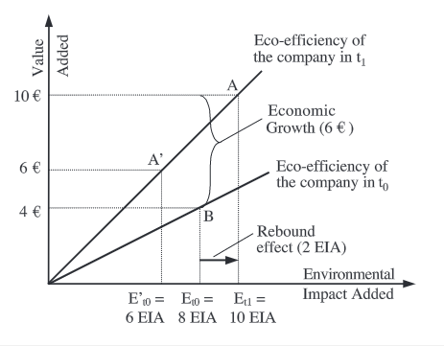
An illustration of the Rebound Effect, taken from Figge and Hahn, 2008 p.179-180
EIA = Environmental Impact Added t0 = Time period 0 t1 = Time period 1
At 8 EIA in time period 0, the eco-efficiency is 0.5€/EIA, (4€/8EUA). In time period 1, the eco-efficiency is 1€/EIA (10€/10EIA). Thus, eco-efficiency has doubled. However, EIA has grown by 2EIA (10-8EIA) owing to an economic growth of 6€. Thus, eco-efficiency has increased but caused an increase in absolute consumption through economic growth.
APPENDIX 8: Systems-based Model of Sustainable Business
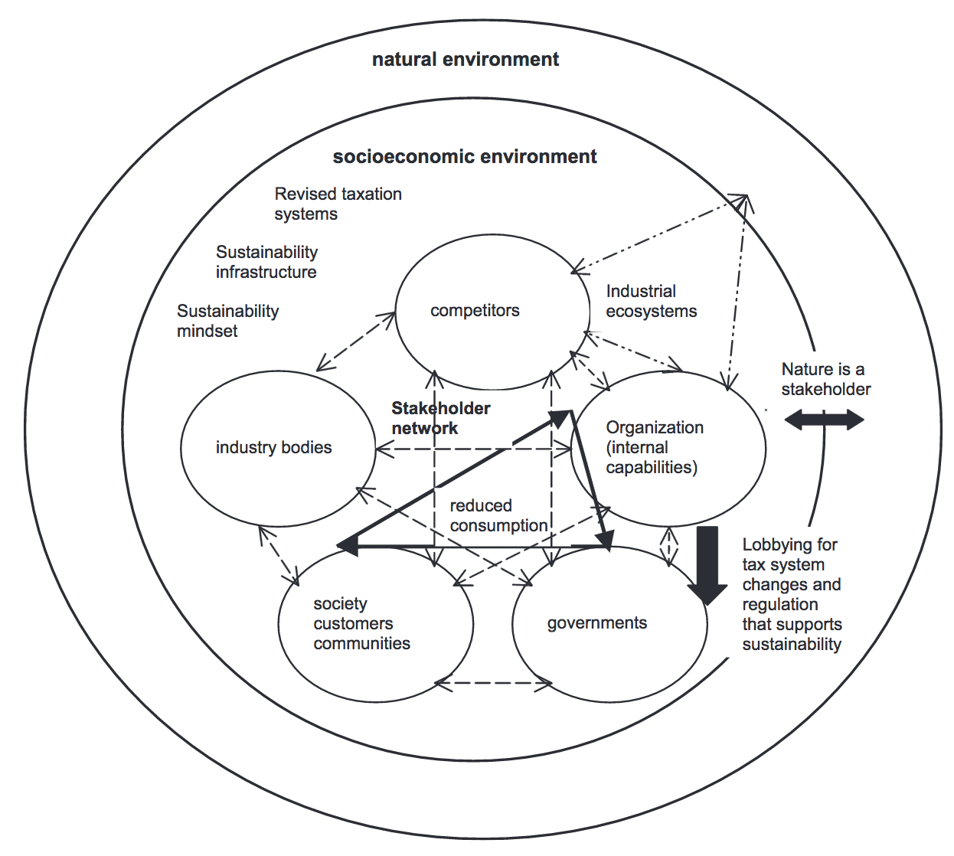
Illustration of a Systems-Based Sustainable Business Model – taken from Stubbs and Cocklin, 2008 p.124
This model demonstrates the interconnectedness of stakeholders (the network dynamics) and includes nature as a stakeholder. This model indicates regulation, fiscal support and consumer behaviour changes are required (reduced consumption) to achieve sustainability. Connections between competitors and organisation indicates collaboration.
Please note, this is an idealistic interpretation of a sustainable business system as no natural capital is transferred into the socioeconomic environment. Also, not all stakeholders are included (such as extended supply-chain organisations, NGOs etc).

minimising environmental impact throughout product lifecycle
minimising company growth impact
environmental resource use relative to economic activity

