2016
Business ethics and sustainability
Jonathan

A Comparative Study Analysing CSR and Sustainable Development Goals of Anonymised Company
Univerity of salford |
Contents
1.0 Introduction 2
2.0 Corporate Social responsibility 2
3.0 Part A – Anonymised Company and CSR 2
3.1 Stakeholder Theory 3
3.2 Anonymised Company Suppliers and Employees 5
4.0 Carroll's Pyramid Theory 5
4.1 Anonymised Company – Legal and Ethical Responsibilities 7
5.0 Part B - Anonymised Company and Sustainable Development Goals 8
5.1 United Nation Sustainability Development Goals (SDGs) 8
5.2 Climate Action 8
5.3 Climate Action 9
5.4 Recommendation for Climate Action 11
6.0 Decent Work and Economic Growth 11
6.1 How Anonymised Company Implements Decent Work and Economic Growth 12
6.2 Recommendation for Decent Work and Economic Growth 13
7.0 Conclusion 13
8.0 Reference List 14

Abstract
The garment industry has been contradicted for being unethical as organisations outsource their products to developing world countries for cheaper labour. Therefore, the purpose of this report will critically asses how Anonymised Company approaches their CSR using two theoretical approaches to evaluate the company. The aim of this report, will understand their ethical decision-making and investigate how they approach their CSR. Further to this, Anonymised Company will be analysed against the ‘United Nation Sustainability Development Goals (SDGs)’ which looks at building an inclusive, sustainable future for people and the planet. Moreover, to understand how the organisation implement these practices with recommendations.

1.Introduction
Businesses are now committing to be more ethical in decision-making which now impacts the reputation and success of the company (Sims, 2003). Businesses are more interested in corporate social responsibility (CSR) which refers to the business responsibilities to society (Amaeshi, Nnodim, and Onyeka, 2013).
Over the years, garment industry has been contradicted for being unethical as organisations outsource their products to developing world countries for cheaper labour (Marosszèky, 2014; Smestad, 2009). Other concerns start to rise, with organisations having CSR issues regarding forced labour, poor wages and child labour (Lueg, Pedersen, and Clemmensen, 2013).
This report will entail research on Anonymised Company, a retail chain which launched in 1982 that offer exclusive collections of stylish clothes, shoes, accessories and home products. With over 500 stores across UK, Anonymised Company have become very popular with profit margins of £821 million in 2016. (Anonymised Company, 2016) Clearly, Anonymised Company are well-known however, the past has shown several CSR crisis regarding child labour, bullying and forced labour.
Therefore, the purpose of this report will critically asses how Anonymised Company approaches their CSR using two theoretical approaches to evaluate the company. The aim of this report, will understand their ethical decision-making and investigate how they approach their CSR. Further to this, Anonymised Company will be analysed against the ‘United Nation Sustainability Development Goals (SDGs)’ which looks at building an inclusive, sustainable future for people and the planet. Moreover, to understand how the organisation implement these practices with recommendations.
The structure of this report will have two sections, the first section will focus on two major issues that Anonymised Company are facing, followed by two CSR theories and evaluate in contrast to Anonymised Company. Furthermore, the second section will focus on sustainable development goals and evaluate how Anonymised Company have implemented two of these goals and provide recommendation for future consideration.

2.Corporate Social Responsibility (CSR)
CSR refers to the expectations of the business and their responsibility to society. It is a good way to contribute to the social welfare and can compensate any negative effects that the business has faced (Blowfield and Murray, 2014). CSR is a method to ensure that businesses conduct itself in a responsible manner and shows the policies, practices and initiatives (Werther and Chandler, 2006). According to, ‘Crane, Matten, and Spence, (2013)’ CSR has different characteristics which are; economic, social, legal, values, environment and discretionary expectations. Anonymised Company, has five main categories in their CSR and they are suppliers, customers, people, community and environment which are all important aspects for Anonymised Company.
3.Part A – Anonymised Company and CSR
Within the next section, Stakeholder and Carrols pyramid CSR theory will be analysed against Anonymised Company and evaluate this in comparison to the CSR of the company.
3.1.Stakeholder Theory
A stakeholder can be an individual, groups or organisations which are interested in the business as it can be anyone who is impacted by the organisation activities. They can be internal stakeholders which are project sponsors, directors and other project managers also, external stakeholder is anyone who is affected outside the organisation (Roeder, 2013).
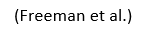
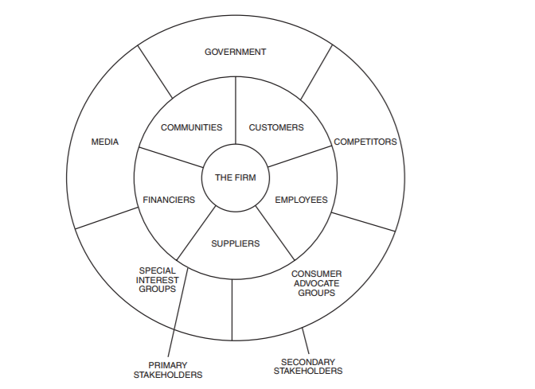
In order to run a business successfully and in line with CSR it is vital to understand who the most important stakeholders are that impact the business. A theory in CSR by, ‘Edward Freeman, 1984’ found it helps address the morals and values in managing a business.

The above theory argues the need to understand the different stakeholders a business can have and understand the power and interest of the stakeholders. The above diagram shows the different stakeholders that businesses need to consider. However, ‘Shirey, (2012)’ argues that stakeholder analysis is valuable but subjectivity could weaken the effectiveness of the analysis. Therefore, this needs to be carefully considered as the theory can help identify and satisfy the needs of the stakeholders.

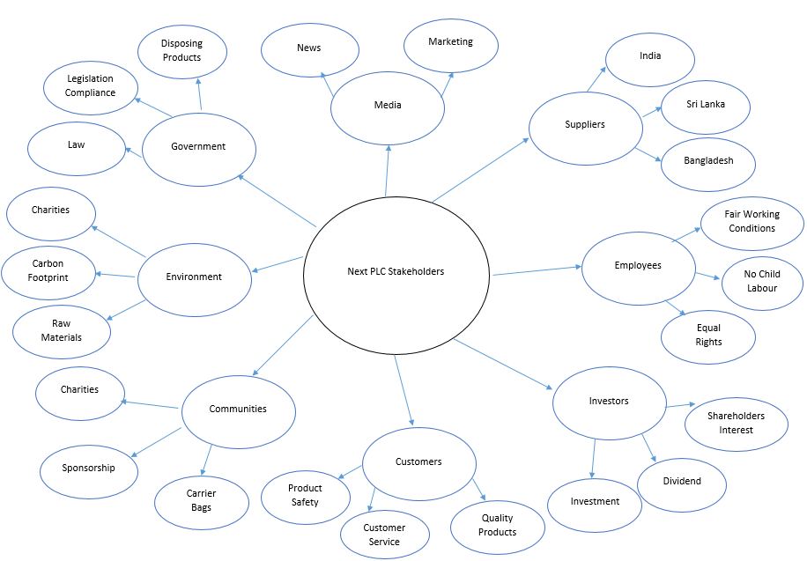

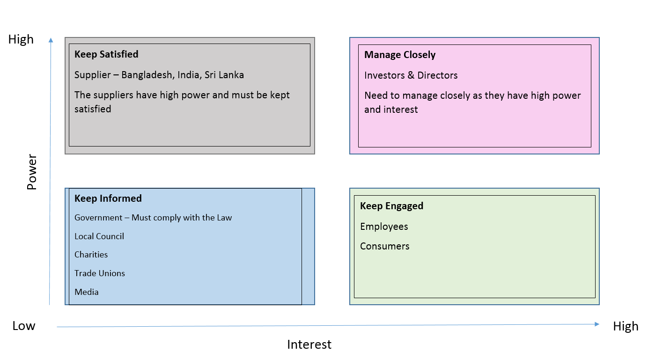

3.2 Anonymised Company Suppliers and Employees
According to ‘Pitel, (2016)’ found children as young as 15 years of age, working in the supply factory in Turkey along with Anonymised Company. Clearly, this is a very big issue and has had negative impacts to the business. The CSR report by Anonymised Company, showed their principles standards which stated; No child labour and fair working conditions (Anonymised Company CSR, 2016, p. 2). However multiple news articles by, ‘BBC; Telegraph; Lusher; Mann, (2016) have proved that Anonymised Company along with other retailers are forcing children to work in Turkey.
Anonymised Company and Anonymised Company were the only retailers to admit in identifying child labour in supplier factories. According to ’Chamberlain, (2010)’ found previous cases of child labour and forced labour at Anonymised Company. A study by ‘Hirsi, (2014)’ has found that Anonymised Company has not published their supplier list and has very little evidence to how external stakeholders affect the organisation. Furthermore, utilising the stakeholder analysis has identified that employees should be getting fair wages, benefits, equal opportunities and safe working conditions. Anonymised Company needs to consider employees as it is an ethical requirement to provide good working condition to all staff.
A way in which this could be avoided is by adopting the stakeholder theory, particularly suppliers and their employees which are a key factor in this case study. By identifying their suppliers they could have eliminated child labour which is part of the ethical trading initiative. Furthermore, Anonymised Company did identify this to be a major problem and quickly taken action to return children to education and provide families with good working condition. As a result of this, Anonymised Company has had major investigations in to the supply chain which has left a bad image of the company.

4.0.Carroll’s Pyramid Theory
Within this section, another case study will be analysed and evaluated against the CSR report and apply this to the Carroll’s pyramid theory.
It is crucial for businesses to embrace social responsibilities to help contribute to society and helps eliminate big issues that are significant when doing business (Carroll, 1991). A way in which businesses can identify problems is utilising ‘Carroll’s Pyramid’ theory which focuses on economic, legal, ethical and philanthropic expectations that a business should adopt for CSR (Buchholtz and Carroll, 2014). The concept of the theory demonstrates that businesses have expectations and obligation to do what is right. Organisations are expected to give back to society and contribute financial, physical and human resources to the community (Baden, 2016).

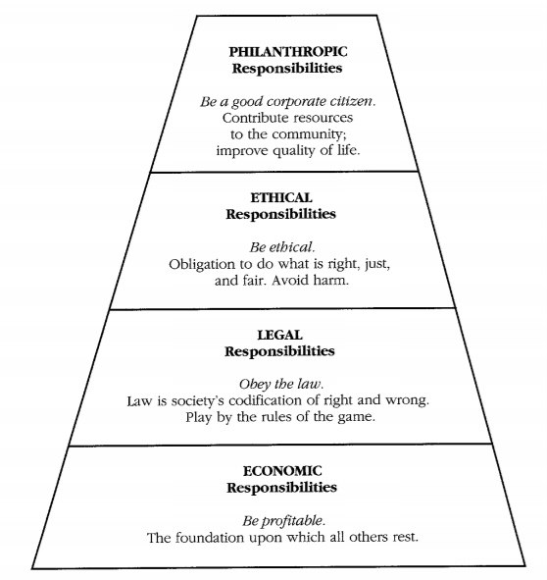

The above diagram shows how the four elements apply to a business. It is important that a company generates profit which is necessary for a company to survive, but they must obey the law which plays a huge role in any business. It is also crucial to be ethical when doing business and to do what is right and fair, and a company can generate a good brand image if they contribute to society.

4.1. Anonymised Company - Legal and Ethical Responsibilities
An article written by, ‘Hills, (2015)’ investigated Anonymised Company and found that the company had committed an illegal act by avoiding their taxes. The report showed Anonymised Company to have £22 million in taxes which they have avoided. The case went to tribunal and Anonymised Company was found guilty in early 2016 and paid out the remaining tax. This clearly is a legal responsibility that the company needs to follow and has now left a bad reputation for the business. Carroll’s Pyramid theory clearly shows the need to have legal responsibilities and Anonymised Company have failed to follow this responsibility.
Another article that has left questions about the company’s ethics, has shown Anonymised Company bullying staff. News articles by, ‘Eccles, (2015); Butler, (2015)’ have reported that Anonymised Company are bullying staff to lose their Sunday premium or they could lose their job. This is a good example of ethical problems that Anonymised Company were facing. However, the company reacted very quickly and have provided a solution by increasing the daily living wage for staff in 2016. (Ruddick, 2015). This was a very good response by Anonymised Company as this was an ethical responsibility needed by the company to satisfy employees.
All in all, the company has demonstrated good relationships with employees and has definitely contributed well to society which is evident in the CSR report. However, the issue still remains with the legal responsibility but the company has now matured and understood their responsibility to the legal requirements and have now stated their taxes in the financial reports of 2016. Overall, Carroll’s Pyramid theory has helped analyse the company and found legal and ethical issues that need to be addressed which can lead to a bad reputation for the company.
5.0.Part B – Anonymised Company and Sustainable Development Goals
Within this part of the report, Anonymised Company will be analysed against the ‘United Nation Sustainability Development Goals (SDGs)’ and evaluate how the organisation implements these practices with recommendations for future consideration.
5.1.United Nation Sustainability Development Goals (SDGs)?
The concept of United Nation sustainable development goals (SDGs) is to build an inclusive, sustainable future for people and the planet. An innovative way to go further to end all form of poverty which includes areas such as; education, health, climate change and environmental protection. It covers three main areas which are, economic growth, social inclusion and environmental protection. It is a strategic action plan to achieve these goals by 2030 that universally apply to all countries, governments, businesses and society (United Nations, 2016).
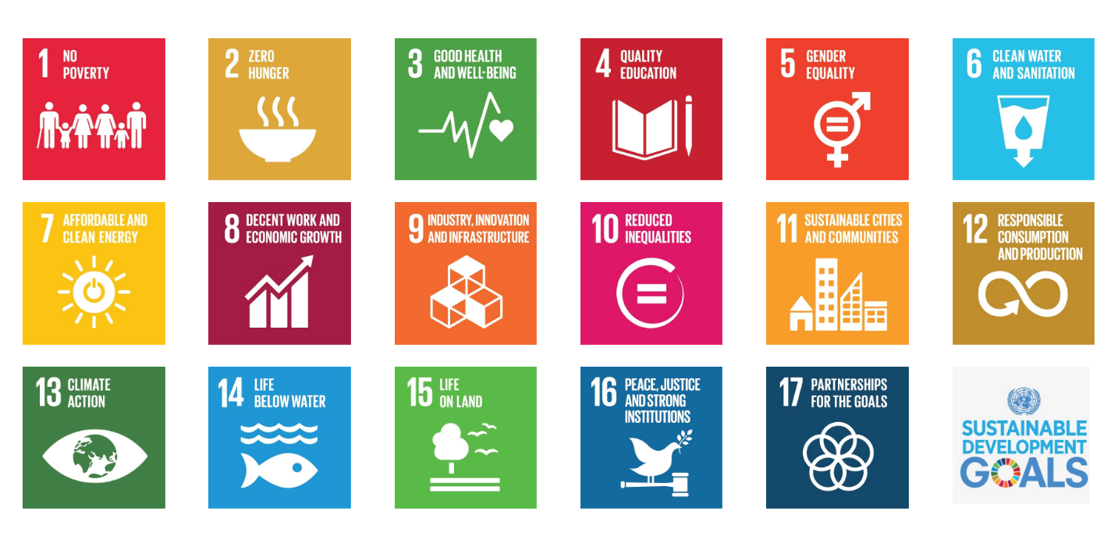

5.2.Climate Action
Climate change is a global issue which is affected by changes in emissions of greenhouse gasses into the atmosphere caused by human activities (BBC Environment, 2016). It impacts environmental, social, political and the economy due to climate change (ICIMOD, 2016).
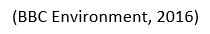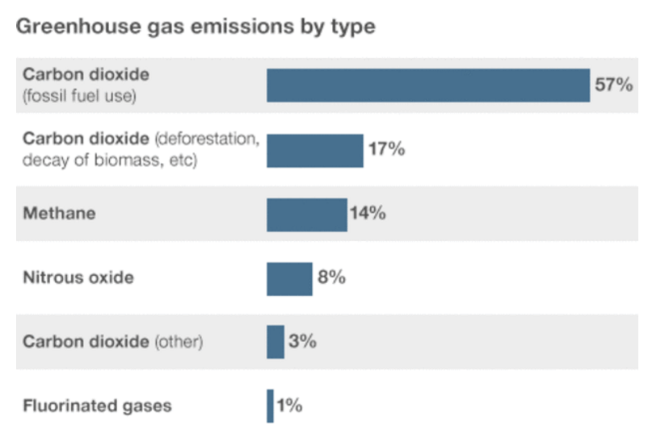
This can cause unpredictable weather conditions, floods, rapid snowmelt caused by the effects of greenhouse gases (BITC, 2015). Overtime businesses will become vulnerable because of reduction in the supply of agricultural products and scarcity of water which will lead to inflation and economic slowdown (United Nation Climate, 2016). Furthermore, there are solutions to climate change through investment in energy efficiency and low-carbon development.
5.3. Anonymised Company and Climate Action
Climate change is a very big concern especially for a garment industry which manufactures clothing, accessories and home furniture’s. Anonymised Company tackles this issue of climate change in multiple ways to help reduce carbon footprint.
One particular way in which they reduce carbon footprint is adopting the ‘Sustainable Clothing Action Plan (SCAP)’ method to help waste reduction in manufacturing. Anonymised Company CSR report shows this project is managed by ‘WRAP’ (Waste and Resources Action Programme) to help minimise resources used and diverting priority materials for landfill. The manufacturing process use chemicals in manufacturing which results in toxins polluting the air, soil and water. Anonymised Company uses WRAP to lower the impact of materials used, recover materials at the end of product life cycle and extend the usable life of clothing. This helped reduce and recycle materials which is very sustainable (Anonymised Company CR, 2016, p. 22).
WRAP, works alongside other major organisations such as, Anonymised Company, Anonymised Company, Anonymised Company which are among 53 retailers that are committed to reduce the environmental impact. They unveiled a plan to reduce 15% in carbon, water and waste to landfill by the year 2020 (WRAP, 2014).

The above table shows the waste and recycling statistics and shows an 18% decrease in carbon footprint. Furthermore, they need to focus on diverting from landfill in order to reduce waste and will impact to the climate. Overall, the company views climate change as a global challenge that needs to be considered and the company does this well by adopting WRAP to reduce their carbon footprint.
5.4.Recommendations for Climate Action
There are other methods that can be utilised to help further reduce carbon footprint that will minimise the impact of climate change. A way in which the Anonymised Company can reduce their carbon footprint is using 3D printing technology that will print the product in a very sustainable way. An article by ‘Spinks, (2014)’ showed that utilising CAD (Computer-Aided Designs) can help reduce the materials used in the manufacturing process which will result in a lower carbon footprint. The literature on 3D printing by ‘McCann et al., (2016) showed how utilising 3D printing technology was used in making clothing for Anonymised Company products. The research shows it helps reduce carbon footprint, reduce production waste, uses recyclable materials and biodegradable materials and can extend the life cycle of a product. This can be adopted by Anonymised Company to help reduce their manufacturing process and reduce wastage, recycle materials and extend product lifestyle.
6.0.Decent Work and Economic Growth
This goal looks at promoting inclusive and sustainable economic growth to provide opportunities for everyone. With unemployment rate increasing over the years, it has now become more imperative for businesses to provide good work opportunities for everyone.

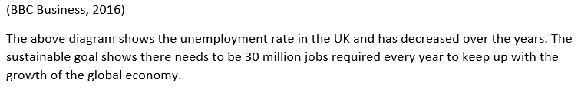
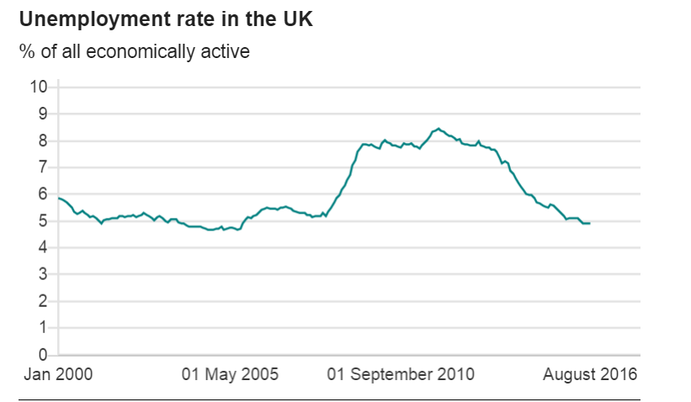
Furthermore, businesses are now aware of these issues and providing job opportunities for people with training, apprenticeships and opportunities to create decent work and increase economic growth.
6.1.How Anonymised Company Implements Decent Work and Economic Growth?
Anonymised Company has employed over 50,000 employees and they are committed to provide an environment where they are treated fairly, supported and motivated. They provide equal opportunities without discriminating, and full consideration is given to all applicants including people with disabilities. The company strongly believes in gender equality and has 44% of female directors employed. The company implements the ‘UN Guiding Principles’ to respect human rights, protect and treat employees fairly (UN Global Compact, 2012).
In 2015 Anonymised Company, adopted the training programme to support over 500 new employees who are now trained to work in the business with opportunities to grow. They have also worked with ARMC (Advanced Manufacturing Research Centre) based at University of Sheffield in training employees in advanced engineering courses to train staff (The University of Sheffield, 2016). In 2016, the company now has more opportunities in career options for people interested in fashion, marketing, IT and HR. The company also allows opportunities to grow with bonuses, share-save and pension schemes. Anonymised Company, also invests in providing employee nursery known as ‘Next Steps’ which has over 200 children and achieved an ‘Outstanding’ Ofsted rating (Next Steps, 2013). This is ongoing commitment to support employees with pre-school arrangements whilst in employment. Overall, the company does approach this sustainable goal by focusing on young people and providing them with the skills needed to work in the business and provide all employees with equal opportunity.
6.2.Recommendations for Decent Work and Economic Growth
A way to attract younger people to work for Anonymised Company, is to create job opportunities through apprenticeships. An apprenticeship combines training while studying as this allows people to work alongside experienced staff, gain relevant skills and experience through work (GOV.UK, 2016). Apprenticeships can have many benefits especially for Anonymised Company, as they can train young people early and allow them to grow within the business. It allows young people to understand how the business operates and learn key employability skills that is transferable (Prospects, 2017.) An article by ‘Kershaw, (2015)’ showed that apprentices can be better as it teaches you the role of the job while studying at the same time. The findings do suggest that Anonymised Company should adopt apprenticeships to train people while they study and this will create good opportunities and is a good approach to produce decent work for all and allow economic growth.
7.0.Conclusion
The purpose of the study was to assess the company from the perspective of corporate social responsibility and understand how Anonymised Company approaches their CSR. The research findings show that although the company shows commitment to their corporate responsibilities, there were news articles that contradicted their ethics. The theories helped analyse the company’s CSR and found ethical issues such as, child labour and avoiding taxes which are very unethical and have damaged the business reputation. However, Anonymised Company have addressed the issues and provided solutions such as, increasing wages for employees which was a good ethical responsibility.
Furthermore, the report has helped evaluate the sustainable development goals (SDGs) and how the company has implemented these practices. Climate action and decent work and economic growth was evaluated and found that the company does implement these according to the CSR and articles have supported this. By adopting 3D printing technology it can help reduce carbon footprint and reduce pollution. Also, the company can recruit through apprenticeships which will help train young people and allow them to grow. Overall, Anonymised Company have demonstrated good awareness of the different issues that impact the business; if they adopt these considerations it will help minimise the risks and improve their ethical decision-making which will result in a positive reputation and success for the company.

  - Individual Written Assignment (60%) and Marking Criteria

As an individual, select a single company from the Britain’s Most Admired List 2015. (or see Appen- dix 1). Please note you will be asked to select this company in your seminar in week 4. Companies are not permitted to be selected by more than one student. By week 4 you should have explored and investigated the company of your choice (and at least one back up company).
When your company has been confirmed by your seminar tutor please answer the following assign- ment question:
    - Critically assess the company from the perspective(s) of business ethics or corpo- rate social responsibility (CSR) using two contrasting conceptual or theoretical ap- proaches.
    - Select two of the Unit ed Nat i ons Sust ai na-
ble Development G oal s (SDGs) and evalu- ate how the organisation is implementing these practices. Provide recommendations on how the company could improve further in these areas
Please ensure you have an introduction, then 2 sections (A and B) and a conclusion.
The range of material you analyse could include information provided by the corporation (e.g. sus- tainability / social / CSR policies and reports) as well as information about the corporation e.g. sto- ries in the media, including specific incidents (scenarios) the corporation has been involved in.

However, you must conduct your own analysis of the material. The detailed report guidelines will be provided during your tutorials. Written assignment will be marked equally out of 100. The word limit is 2500 words (10% above or under). Exceptions receive a 10% final mark penalty.

DEADLINE: 4pm – January 6th 2017
Source: sustainabledevelopment.un.org/sdgs
Feedback
You are entitled to feedback on your performance for all your assessed work. This is accomplished by a member of academic staff providing your mark and associated comments which will relate to the achievement of the module’s intended learning outcomes and the assessment criteria you were given for the task when it was first is- sued. This feedback will be available online via Turnitin. The marker of your assignment will in- clude feedback on written assignments that in- cludes answers to these three key questions:

- What is your overall feedback?
- How does your assignment compare to the mark- ing criteria?
3. How can you improve in the future?

Assignment Guidance
Reports will be marked based on the following criteria, please consider the following points:
- The adoption and analysis of suitable and relevant theory relevant to the company under investigation.
- Critical analysis should be included which explores the topics in question.
- Reports should answer the assignment question specifically
- A suitable report structure should be adopted.
- Both questions should be given a proportionate amount of preparation and have an equal word count.
- Valid arguments should be presented and support- ed with evidence.
- A coherent introduction and overall conclusions should be included
- All material must be reference correctly within the text itself (main body) (see page 27).
- A thorough and complete reference list must be included at the end of the essay in accordance to Harvard Standard (APA 6th).

Written Assignment

8.0 References List
- Amaeshi, K., Nnodim, P. and Onyeka, O. (2013) Corporate social responsibility, entrepreneurship, and innovation. New York: Routledge Taylor & Francis Group, pp. 1-4.
- Baden, D. (2016). A reconstruction of Carroll’s pyramid of corporate social responsibility for the 21st century. International Journal of Corporate Social Responsibility, 1(1), 4–8. doi:10.1186/s40991-016-0008-2
- BBC (2016) Child refugees in turkey making clothes for UK shops. Retrieved December 31, 2016, from
- BBC Business (2016). UK unemployment rate holds steady. BBC Business. Retrieved January 06, 2017, from http://www.bbc.co.uk/news/business-37701672
- BBC Environment (2016) What is climate change? Retrieved 3 January, 2017, from http://www.bbc.co.uk/news/science-environment-24021772
- BITC. (2015). Tackling climate change. Retrieved January 3, 2017, from http://www.bitc.org.uk/issues/environment/tackling-climate-change
- Blowfield, M. and Murray, A. (2014) Corporate responsibility. 3rd edn. Oxford, United Kingdom: Oxford University Press, pp. 4-6.
- Buchholtz, A.K. and Carroll, A.B. (2014) Business and society: Ethics, sustainability, and stakeholder management. 9th edn. Stamford, CT, United States: Cengage Learning, pp 27-30
- Butler, S. (2015) Anonymised Company accused of telling staff to give up Sunday bonus or lose jobs. Retrieved 31 December, 2016, from https://www.theguardian.com/business/2015/may/11/next-sunday-bonus-shop-workers-contracts
- Carroll, A. B. (1991). The pyramid of corporate social responsibility: Toward the moral management of organizational stakeholders. Business Horizons, 34(4), 39–48. doi:10.1016/0007-6813(91)90005-g
- Chamberlain, G. (2010) Gap, next and M&S in new sweatshop scandal. Retrieved December 31, 2016, from https://www.theguardian.com/world/2010/aug/08/gap-next-marks-spencer-sweatshops
- Crane, A., Matten, D. and Spence, L. (2013) Corporate social responsibility: Readings and cases in a global context. 2nd edn. London, United Kingdom: Routledge.
- Eccles, L. (2015) Next ‘bullied staff over Sundays’. Retrieved December 31, 2016, from http://www.dailymail.co.uk/news/article-3077506/Next-bullied-staff-Sundays-Retailer-forced-employees-accepting-pay-cut-working-refused-redundant.html
- ECHA. (2016). Regulations of REACH. Retrieved December 30, 2016, from https://echa.europa.eu/regulations/reach
- Freeman, E.R., Harrison, J.S., Wicks, A.C., Bid, H., S, J., Parmar, B.L. and de Colle, S. (2010) Stakeholder theory: The state of the art. Cambridge: Cambridge University Press, pp. 42-47.
- GOV.UK. (2016, October 25). Become an apprentice. Retrieved January 4, 2017, from https://www.gov.uk/apprenticeships-guide/overview
- Hills, J. (2015) Clothing chain next landed with a £22 million tax bill. Retrieved December 30, 2016, from http://www.itv.com/news/2015-05-19/next-tried-moving-its-profits-around-its-empire-in-an-attempt-to-minimise-its-tax-bill/
- Hirsi, N.H. (2014) A Comparative Study of the CSR Communication in the Garment Industry. Master Thesis. Business & Social Sciences, Aarhus University. Retrieved December 31, 2016, from http://pure.au.dk/portal-asb-student/files/76608964/Master_Thesis.pdf
http://www.bbc.co.uk/news/business-37716463
- ICIMOD. (2016). Climate change and business. Retrieved January 3, 2017, from http://www.icimod.org/?q=3488
- Kershaw, A. (2015, October 9). No degree? No worries - the apprentices earning more than university graduates. Retrieved January 5, 2017, from http://www.mirror.co.uk/money/apprentices-earn-more-university-graduates-6597455
- Lueg, R., Pedersen, M.M. and Clemmensen, S.N. (2013) ‘The role of corporate sustainability in a low-cost business model - A case study in the Scandinavian fashion industry’, Business Strategy and the Environment, 24(5), pp. 344–359. doi: 10.1002/bse.1825.
- Lusher, A. (2016) Refugee children ‘making marks & Spencer clothes’ in Turkish factories, BBC claims. Retrieved December 31, 2016, from http://www.independent.co.uk/news/child-labour-sweatshops-refugees-marks-and-spencer-panorama-clothes-sold-in-uk-britain-british-high-a7376706.html
- Mann, T. (2016) Syrian refugee children found working in next and H&M factories. Retrieved December 31, 2016, from http://metro.co.uk/2016/02/01/syrian-refugee-children-found-working-in-next-and-hm-factories-5656671/
- Marosszèky, A. (2014) ‘Dishing up diverse issues of ethics in the fashion industry’, Fashion Theory: The Journal of Dress, Body & Culture, 18(3), pp. 361–364. doi: 10.2752/175174114x13938552557961.
- McCann, J., Albaugh, L., Narayanan, V., Grow, A., Matusik, W., Mankoff, J., & Hodgins, J. (2016). A compiler for 3D machine knitting. ACM Transactions on Graphics, 35(4), 1–11. doi:10.1145/2897824.2925940
- Anonymised Company CR. (2016). CORPORATE RESPONSIBILITY REPORT. Retrieved January 01, 2017, from http://www.nextplc.co.uk/~/media/Files/N/Next-PLC-V2/documents/cr-reports/cr-2016.pdf
- Anonymised Company (2016). At a glance. Retrieved December 29, 2016, from http://www.nextplc.co.uk/about-next/at-a-glance
- Next Steps. (2013). Next steps nursery. Retrieved January 4, 2017, from http://www.nextstepsnursery.co.uk/learning.html
- Pitel, L. (2016). Syrian refugee children found working in next and H&M factories. The Independent - Middle East. Retrieved December 29, 2016, from http://www.independent.co.uk/news/world/middle-east/syrian-children-found-working-for-uk-clothing-suppliers-including-next-and-hm-a6845431.html
- Prospects. (2017). Should I do a degree or an apprenticeship? Retrieved January 4, 2017, from https://www.prospects.ac.uk/jobs-and-work-experience/apprenticeships/should-i-do-a-degree-or-an-apprenticeship
- Roeder, T. (2013) Managing project stakeholders: Building a foundation to achieve project goals. United States: Wiley, John & Sons.
- Ruddick, G. (2015) Next chief says ‘national living wage’ could drive up inflation. Retrieved December 31, 2016, from https://www.theguardian.com/business/2015/sep/10/next-chief-says-national-living-wage-could-drive-up-inflation
- Shirey, M.R. (2012) ‘Stakeholder analysis and mapping as targeted communication strategy’, JONA: The Journal of Nursing Administration, 42(9), pp. 399–403. doi: 10.1097/nna.0b013e3182668149.
- Sims, R.R. (2003) Ethics and corporate social responsibility: Why giants fall. Westport, CT, United States: Greenwood Press, pp. 4-7.
- Smestad, L. (2009) ‘The sweatshop, child labor, and exploitation issues in the garment industry’, Fashion Practice The Journal of Design Creative Process & the Fashion Industr, 1(2), pp. 147–162. doi: 10.2752/175693809x469139.
- Spinks, R. (2014,). From Parisian catwalks to your home, 3D printing is democratising fashion. The Guardian. Retrieved January 01, 2017, from https://www.theguardian.com/sustainable-business/sustainable-fashion-blog/paris-catwalk-3d-printing-democratise-fashion
- Telegraph (2016) M&S and ASOS among British retailers found employing child refugees in factories. Retrieved December 31, 2016, from http://www.telegraph.co.uk/news/2016/10/24/ms-and-asos-among-british-retailers-found-employing-child-refuge/
- The University of Sheffield (2016) AMRC apprentices. Retrieved December 30, 2016, from https://www.sheffield.ac.uk/news/nr/amrc-apprentices-to-take-show-on-the-road-thanks-to-generous-donation-by-first-group-plc-1.572882
- UN Global Compact. (2012). Guiding principles on business and human rights. Retrieved January 04, 2017, from http://www.ohchr.org/Documents/Publications/GuidingPrinciplesBusinessHR_EN.pdf
- United Nation Climate. (2016). Climate Action. Retrieved from http://www.un.org/sustainabledevelopment/wp-content/uploads/2016/07/16-00055_Why_it_Matters_Climate_Action_Business_letter_size_1p.pdf
- United Nations (2016) United Nations sustainable development agenda. Retrieved January, 02, 2017, from http://www.un.org/sustainabledevelopment/development-agenda/
- Werther, W.B. and Chandler, D.B. (2006) Strategic corporate social responsibility: Stakeholders in a global environment. 2nd edn. Thousand Oaks, London, UK: SAGE Publications, pp. 3-6.
- WRAP, (2014). Clothing sector agrees challenging targets to cut environmental impact by 15%. Retrieved December 30, 2016, from http://www.wrap.org.uk/SCAP2020targetstraderelease

