Thea Aursnes
3rd year BSc Management at Royal Holloway University of London

Table of Contents
0.0 Abstract 2
1.0 Introduction 2
2.0 Company Overview 3
3.0 RR’s Strategic Business Context 3
3.1 PESTEL 3
3.2 SWOT 4
4.0 Responsible Management Challenge 4
5.0 Recommendations through HRM 7
5.1 Existing Responsible Management System 8
5.2 Improved Training 8
5.3 Cultural Change 9
5.4 Eliminate Intermediates 10
5.4 Summary of Recommendations 12
6.0 Conclusion 13
7.0 Details of Original Assignment 14
8.0 Bibliography 15

Responsible Management Challenge at RR

Abstract
This report analyses a responsible management issue regarding corruption at RR (anonymised company name). As well as analysing in what way these corruption claims was an actual issue for RR, the report looks into how the HRM function could be improved to solve this issue. The recommendations made in this report are: to improve employee and management training, change the organisational culture, and eliminate the use of intermediates when handling contracts.
It is important to note that this report was written in November to December 2016, more than 2 months before the corruption claims were proved in January 2017. Hence, it is based on analysing particular events in the company which indicated that an even greater issue might arise later. Evidently, as the corruption claims now are demonstrated to be true, the issue might be even greater for RR than when this report was written. However, the recommendation suggestions are still realistic.

1.0 Introduction
For the past years, RR have faced numerous claims of being corrupt in several countries (Panorama, 2016; Lord, 2013), and the issue in India will be the main focus of this report. Furthermore, it will be analysed how the HRM function at RR may address this on-going responsible management challenge. The reason why this corporate function is found most relevant to deal with the issues, is because corruption is arguably a problem that has to do with the employees in the corporation, and the HRM function is evidently the best corporate function when it comes to dealing with employees.
However, their marketing function could also have dealt with the issue to fix RR’s reputation, which has face serious damage due to the claims (Marsh and Clark, 2015). Nonetheless, the ultimate aim should be to solve the root to the issue, not one of the negative outcomes of it. On that note, the accounting function could also be a relevant function to deal with the issues. Nevertheless, this function could have arguably only discovered the issue, while the HRM function is better equipped to solve it.
The outline of the report is presented in the table of content at page 1.

2.0 Company Overview
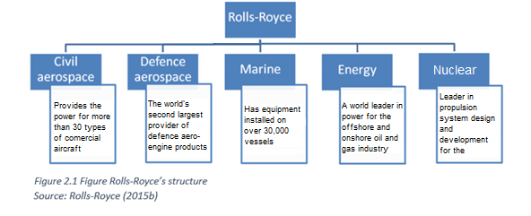
RR is an international corporation (Yusuf et.al, 2004), operating in more than 50 countries. For the past decades after WW2, they have been a diversified company operating in several industries (see figure 2.1), though their main industry is civil and defence aerospace, where they combined have a revenue of £8,968m (RR, 2015a).

3.0 RR’s Strategic Business Context
RR, like any other organisation has a strategic business context that is unique to them. There are several techniques to analyse the strategic business context, such as conducting a PESTEL analysis to analyse the factors influencing the external environment (see figure 3.1), and creating a SWOT analysis to understand the internal environment of the firm, as well as for “assisting the formulation of strategy” (Dyson, 2004: 631) (see figure 3.2).

3.1 PESTEL
Political | Economic | Social | Technological | Environmental | Legal
- Increase in terrorism might harm demand  - Government policies  - Receiving government support | - Unpredictable demand  - Fuel price keeps increasing  - Volatility in oil prices | - Globalisation  - Increase in flights  - Challenges with cultural differences  - Responsibility to reduce emission | - Potential for further innovation  - R&D becoming increasingly important | - Weather might affect flights  - Climate changes makes expansion more difficult | - Environmental standards on e.g. pollution  - Risk of breaking anti-corruption in emerging markets
Figure 3.1: PESTEL analysis of RR’s external environment
Source: Monbiot, 2016; Martinez-Jurado and Moyano-Fuentes (2014); RR (2015a); Rebolledo and Nollet (2011); Corallo et.al (2010); Shen et.al (2014); Laasch and Conway (2015); Yusuf et.al (2004)

3.2 SWOT
 | Helpful | Harmful
Internal | Strengths  - Major player in aero-engines manufacturing  - Great global reach  - High capacity and skilled workforce  - High focus on R&D  - Strong order book | Weaknesses  - Way of dealing with legal affairs  - Lack of commitment in environmental issues  - Products are energy driven  - Nuclear producers, in terms of the safety aspect and responsibility
External | Opportunities  - Increased demand for commercial airplane engines  - New planned acquisitions  - Increased demand for turbine helicopters  - Knowledge transfer  - Attractiveness to high skill labour  - Government funding | Threats  - High level of competition  - Government policies compatibilities  - Major risk for supply chain  - Natural disaster and weather  - Government funding may decrease
Figure 3.2: SWOT analysis of RR
Source: Laasch and Conway (2015); RR (2015a); Martinez-Jurado and Moyano-Fuentes (2014); Tveten and Løset, (2012); Panorama (2016)

4.0 Responsible Management Challenge
This section will analyse a specific ethical issue RR is facing, namely being involved in corruption in India. The investigation has been on-going since 2011 (Collingridge, 2016), and have harmed RR’s reputation tremendously (Marsh and Clark, 2015). The allegation states that RR have “secured multimillion-dollar contracts in foreign jurisdictions by using agents who paid bribe” (Pegg et.al, 2016: 1). In general, the bribes aim at ensuring airlines are using engines produced by RR (Panorama, 2016). Although it is not illegal to hire middlemen, using them to pay bribe is evidently illegal (Lord, 2013; Mitchell, 2015). Furthermore, there are sufficient evidences demonstrating that RR is using intermediates in countries where corruption is widespread, such as India, to win valuable contracts (Panorama, 2016; Collingridge, 2016; Marsh and Clark, 2016; Pegg, 2016).
This ethical problem is doubtless a major responsible management challenge for RR. RR have a moral obligation to act upon the interest of their stakeholders, including the society in which they operate (Griseri and Seppala, 2010; RR, 2015b). It is suggested that corruption is a barrier to a country’s economic development (Drugov et.al, 2014), as it weakens trust in institutions and steps on the basic principles of democracy (Olken and Pande, 2011). Additionally, corruption is slowing down economic development as it fosters an unethical business environment where competitive advantage is gained through bribers rather than through price or quality (Osuji, 2011; Porter 1980). As India is still a developing country, they cannot afford any obstacle to their economic growth. RR is notwithstanding taking part of slowing down India’s economic development and thus affecting the millions of people living in the county.
Nonetheless, it is also argued that business exists to make a profit (Carroll and Shabana, 2010), and that their impact on society should not be their concern. In that sense, one can argue that the corruption have had a positive impact on RR as briber has helped them gain valuable contracts that they could not otherwise win (Panorama, 2016; Osuji, 2011). A leaked, confidential email regarding RR stated that “spending $2,684 on a key decision maker is worth 100 time that value. Without which we would have no contract in our hands now” (Panorama, 2016: 4.05). Thus, sometimes unethical behaviour is the most profitable way to do business (Frank, 2004), and might be necessary to survive in the market (Geo-Jaja and Magnum, 2000).
Cost | Expenses
Direct cost | Direct bribery payment
 | Investigating of issue
 | Lawyers
Indirect cost | Loss of customers due to bad reputation
 | Loss of investors
 | Loss of investing opportunities
However, corruption is still a major challenge for the way RR is doing business as it is assumed it will increase the cost of doing business with 10% (OECD, 2014). Table 4.1 shows a selection of the expenses RR have had in relation to corruption, and from figure 4.1 one can see a decline in their economic performance ever since the unethical behaviour became an issue.
Table 4.1: Some of the cost associated with corruption
Source: OECD (2014); Hess and Ford (2008)

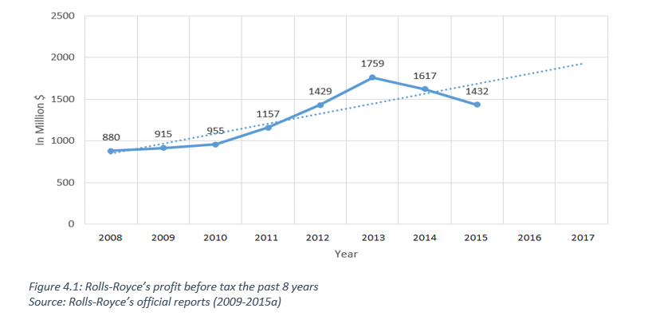
Notwithstanding, RR state that business ethics are crucial to the way they operate and that they “have a zero tolerance approach to any form of ethical misconduct, bribery or corruption” (RR, 2015b: 49). Their Global Code of Conduct applies to all employees, and are demanding ethical behaviour from all who are in some way related to the corporation. However, corruption have the greatest negative impact on business when the corporation claims to have official ways of dealing with it, but still get caught up in scandals regarding it (Crane and Matten, 2016). In addition, RR admit that historical issues concerned with bribery and corruption in oversea markets have undermined confidence in the business in the past (RR, 2015b). Nevertheless, it seems like these historical issues are either still present, or returning. Hence, RR might face enormous challenges due to this issue.
The most cornering impact this ethical issue might have on RR, is the impact it may have on their reputation (Marsh and Clark, 2015). Corporate reputation is a significant resource in today’s modern business environment, and vital to gain competitive advantage (Deephouse et.al, 2016). A study show that most people will pay more for products and services that are come from corrupt-free corporations (Yeoh, 2012). Hence, although it might be argued that RR need to pay bribes to land contracts, it is likely to have negative effect on the future reputation, which is likely to impact their access to human resource, future customers and investors, and in the end the cash flow of the company.
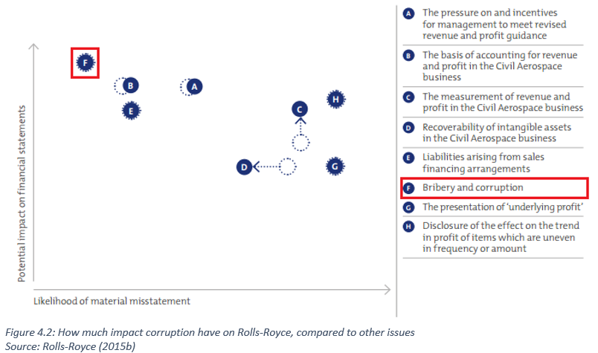
Moreover, RR acknowledge that they operate in countries where corruption is a great risk, and that large part of their business includes contracts with customers, which are “activities [that] are highly susceptible to the risk of corruption” (RR, 2015b: 171). Hence, corruption is proven to be a major responsible management challenge for RR, which might have potential negative impact on the company, particularly with regard to their financial statement (see figure 4.2).
Several of the middlemen RR have used have face hard penalties for being involved in this ethical issue (Panorama, 2016), and RR risk facing enormous fines, which is what happened to BAE Systems, one of RR's main competitors, when they pleaded guilty for paying bribers (Sharman, 2010). Such penalties take up vital resources, like fund and personnel, which evidently will be an inefficient use of their resources. This inefficiency is not something RR can afford as they operate in a highly competitive environment (Tveten and Løset, 2012). Moreover, employees may face jail time (Mitchell, 2015), which undoubtedly will make RR an unattractive employer (Davidson, 1990).

5.0 Recommendations through HRM
Although breaking corruption-laws is a big risk in countries like Russia, India, and China, corruption issues are absolute manageable (Venkatesan, 2013). Hence, RR is fully responsible for their actions, because bribery is very much a choice which “often simply reflects bad judgement” (Venkatesan, 2013: 159).
In order to manage such crisis, it is vital to have employees that truly understand the law in the local area (Venkatesan, 2013), as they will have a better understanding of how to act in said country without facing ethical dilemmas due to bad judgement. Thus, as stated, RR’s most critical corporate function to deal with this ethical challenge, is arguably their HRM function.

5.1 Existing Responsible Management System
RR have completed a throughout review of their ant-corruption policies including the use of intermediaries (Lord, 2013), and they claim they have absolute zero tolerance for corruption and bribery. Moreover, RR state that they are “strengthening of the ethics, anti-bribery and corruption, compliance and export control team” as well as having a legal team investigating the claims (RR, 2015b: 56). Besides, they provide ethical training for their managers and employees, as a part of their responsible management system. However, as corruption is still an issue, three recommendations are made in how they can improve their responsible management system.

5.2 Improved Training
97% of RR’s employees have gone through ethical training, and their strategic aspiration is to ensure that 100% of their employees do so (RR, 2015b). However, their training is evidently not good enough as unethical behaviour still occurs. Hence, the first recommendation is that the HR department improve the ethical training their employees receive. First, the training should be relatable and more interactive in order to give better results (Hughey and Mussung, 1997). Additionally, training should be repeated annually to make sure employees are up to date on how to tackle ethical dilemmas, as it is argued that employees will lose 90% of skills gained from training within the first year (Balkovic et.al, 2016). The ethical training should be embed RR’s code of conduct into the work that is done on a day-to-day basis (Hughey and Mussung, 1997), so that it coexists with RR's strategy of engineer excellence (RR, 2015b).
However, additional and improved training is expensive and time-consuming, and RR’s HR department might needs to hire additional human resources to ensure better training. With RR's declining reputation (Marsh and Clark, 2015), they might face constraint when hiring new people, as people tend to be less interested in working for corporations with ethical issues (Davidson, 1990; Borikar and Goodban, 1989). Moreover, RR might face financial resources constraint, as their revenue is declining (RR, 2009-2015a), and they arguably hence have to cut down on expenses. In addition, there is no guarantee that the training will change the employees’ ethical behaviour (Sööt, 2012).
Nonetheless, better and additional training is still absolutely achievable within the capabilities of RR existing responsible management system. Since ethical training is already a part of their system (RR, 2015b), it would not be difficult to implement better and additional training, the only challenge is the mentioned resource constraints. By making additional training is compulsory for their employees, RR will ensure they are better equipped to deal with ethical issues.

5.3 Cultural Change
However, it is argued that training people to act in an ethical way will in most cases not simply lead to better ethical behaviour among the workforce (Sööt, 2012). Instead, it will be more effective to ensure the employees understand the importance of ethical behaviour, and why corruption is an unwanted. This leads to the second recommendations, RR need to change their corporate culture in order to foster ethical behaviour.
Nevertheless, changing culture is difficult. First, the employees must understand why there is a need for change (Kim and Mauborgne, 2015), and this might be the biggest hurdle to overcome (Kaptein, 2009; Alvesson and Sveningsson, 2015). Furthermore, employees must be motivated to change (Kim and Mauborgne, 2015), and penalties must be provided for those who refuse to. Moreover, as changing corporate culture is time-consuming (Alvesson and Sveningsson, 2015), and RR have to deal with the ethical issues as soon as possible (Panorama, 2016), time as a resource is evidently a large constraint to this recommendation. Notwithstanding, the sooner the changes begin, the sooner it will yield results. Since corruption is increasing globally (Hess and Ford, 2008), one can assume that RR might also face these issues in the future. Hence, changing the culture will make it easier for them to solve future ethical problems.
As RR have a strategic aspiration of doing better business with absolute no corruption (RR, 2015b), changing the culture might be the only way to achieve their goal. However, this is a change that cannot easily be implemented in RR's responsible management system, as it essentially requires to change big parts of it. Nevertheless, changing a corporate culture is not impossible (Kaptein, 2009), and BAE Systems were able to change their corporate culture after their corruption scandal (Dietz and Gillespie, 2012; Lord, 2013). Thus, RR should be able to change as well.

5.4 Eliminate Intermediates
Thirdly, the HRM function in RR should stop using third party intermediates immediately. RR have already cut down the use of intermediates to bargaining contracts (RR, 2015b) as a part of their responsible way of managing the ethical issues. However, as evidence suggest that the intermediates are the main reason for their corruption issues (Panorama, 2016), RR must arguably eliminate all contact with such third parties. RR cannot guarantee the intermediates they use have undertaken ethical training, as they are not a part of their workforce. Hence, although their strategic aspiration is to ensure all employees undertake ethical training (RR, 2015b), the intermediates might be the greatest issue, as they cannot guarantee this for them.
Instead, RR should ensure that all contracts with customers are handled by their own employees, as this will help the company reach their strategic aspiration of moral excellence and zero corruption (Drugov et.al, 2014; RR, 2015b). The main challenges here is that they have to move around their human resource and train them in contract bargaining. Alternatively they can hire additional human resources, working like the intermediates are currently doing, but as a fully part of RR’s workforce. This will guarantee RR that the people bargaining contract on their behalf have undertaken ethical training. However, in South-Asia, there is a human resource constraint on talented employees (Veldhoen et.al, 2012), evidently making hiring new skilled employees in this area, where the contract issues have arose, challenging.
Notwithstanding, the implementation of this recommendation is arguably rather easy, and RR have already to some extent already started doing it. However, they must develop what they have started, and fully stop using intermediates, in order to ensure ethical behaviour to a greater extent, and to truly have zero corruption in their business activities, as their strategic aspiration states.

5.4 Summary of Recommendations
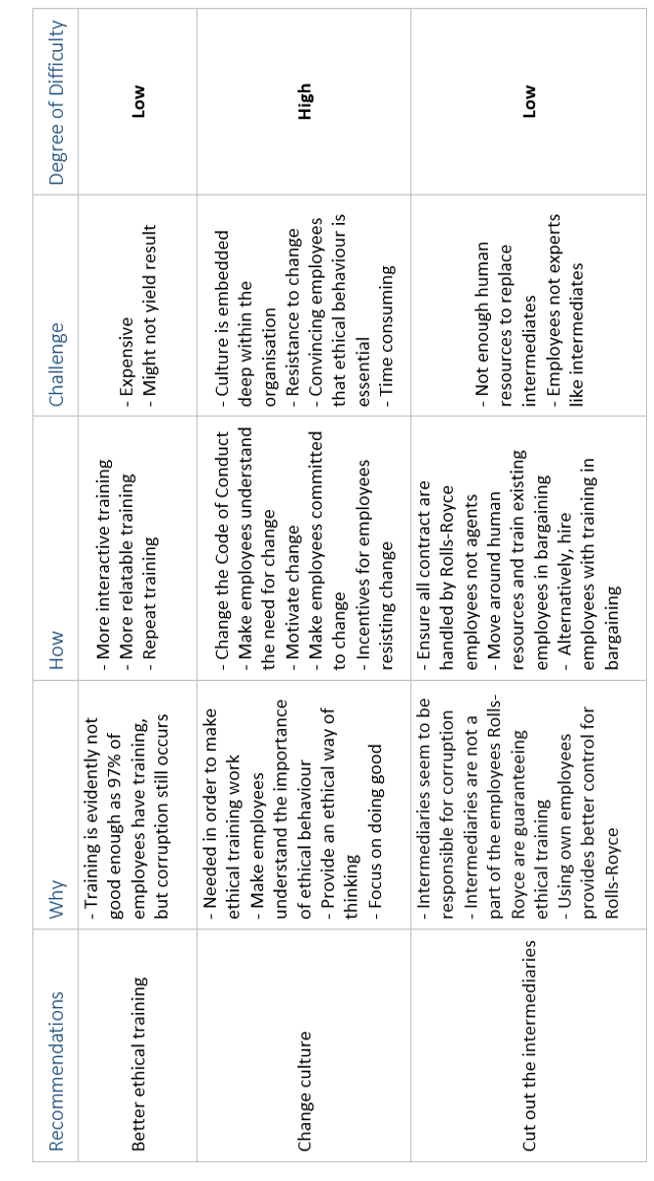

6.0 Conclusion
Conclusively, RR is facing a serious responsible management challenge through unethical behaviour in India and other emerging countries around the world. Although bribery is arguably helping them win customer contracts (Pandora, 2016; Geo-Jaja and Mangum, 2000), they are still causing them financial problems and long-term reputation damage (Marsh and Clark, 2015), which will certainly impact their future customer-base. History shows that RR have had problems with corruption in the past, which have undermined confidence in the business (RR, 2015b), and in addition to risk facing enormous fines, they and they are putting their employees in danger of facing legal penalty.
Furthermore, as a corporation, RR have the moral obligation to do good (Griseri and Seppala, 2010; RR, 2015b), and corruptive behaviour has a negative impact in the countries where they operate. As well as slowing down India’s economic development (Olken and Pande, 2011), they are fostering a culture of unethical behaviour where competition is based on bribery rather than price and quality (Osuji, 2011).
Fortunately, RR can manage this responsible management challenge through their HRM function. First, as the ethical training is evidently not working, it must be improved. However, there is no guarantee that this will manage RR’s unethical behaviour. In addition, it might be a waste of resources. Thus, RR must perhaps change their corporate culture. Nonetheless, although this is likely to yield better results, it is an extremely difficult and time-consuming task (Kaptein, 2009). The third recommendation is thus to simply cut out the intermediaries dealing with their contracts, and make their own employees deal with this instead. Although, this might be a bit difficult due to South-Asia’s constraint on talented human resources (Veldhoen et.al, 2012), it will provide them with better control, and arguably ensure ethical behaviour to a greater extent.

7.0 Details of Original Assignment

Identify one major responsible management challenge the company faces and then choose which one of the following corporate functions studied on the course you consider most relevant to addressing the challenge and why:
- marketing,
- HRM,
- accounting/controlling, or
- business information systems.
Analyse the company’s strategic business context and make recommendations for how the company should address the responsible management challenge identified through the corporate function chosen. Your recommendations should explicitly take into account the company’s strategic aspirations and the resource constraints it faces. You should clearly indicate and justify how these recommendations are practicable and realistic in the context of the company’s existing systems for addressing social, environmental and/or ethical issues, and how these systems could be further developed and changed to fully implement your recommendations.

8.0 Bibliography
Alvesson, M. and Sveningsson, S. (2015). Changing organizational culture: Cultural change work in progress. New York: Routledge
Balkovic, M., Dzelalija, M., and Simovic, V. (2016). ‘Stakeholders' attitudes and expectations in respect to value and implementation principles of recognition of prior learning in Croatia’, International Journal of Innovation and Learning, 20(4), 399-421
Borikar, A. and Goodban, A. (1989). ‘Recruitment: an investigation into recruitment problems in occupational therapy’, The British Journal of Occupational Therapy, 52(10), 392-394
Carroll, A. B. and Shabana, K. M. (2010). ‘The business case for corporate social responsibility: A review of concepts, research and practice’, International journal of management reviews, 12(1), 85-105
Collingridge, J. (2016). ‘RR in new drive to close down corruption probes’, The Times, 7th of August, [Online], Available at: http://www.thetimes.co.uk/article/RR-in-new-drive-to-close-down-corruption-probes-stvw7c9tx (Accessed 5th November 2016)
Corallo, A., Lazoi, M., Margherita, A., and Scalvenzi, M. (2010). ‘Optimizing competence management processes: A case study in the aerospace industry’, Business Process Management Journal, 16(2), 297-314
Crane, A. and Matten, D. (2016). Business Ethics (4th edition). Oxford: Oxford University Press
Davidson, D. K. (1990). ‘On corporate reputation: a reply to Dobson’, Business and Society, 29(1), 39-41
Dietz, G., and Gillespie, N. (2012). ‘Recovery of Trust: Case Studies of Organisational Failures and Trust Repair’, Institute of Business Ethics, 5(4)
Deephouse, D. L., Newburry, W., and Soleimani, A. (2016). ‘The effects of institutional development and national culture on cross-national differences in corporate reputation’, Journal of World Business, 51(3), 463-473
Drugov, M., Hamman, J., and Serra, D. (2014), ’Intermediaries in corruption: an experiment’, Experimental Economics, 17(1), 78-99
Dyson, R. G. (2004). ‘Strategic development and SWOT analysis at the University of Warwick’, European journal of operational research, 152(3), 631-640
Frank, R. (2004). What Price the Moral High Ground? How to Succeed without Selling your Soul. New Jersey: Princeton University Press
Geo-Jaja, M.A. and G.L. Mangum (2000). ‘The Foreign Corrupt Practices Act’, Journal of Business Ethics, 24, 245-255
Griseri, P. and Seppala, N. (2010). Business Ethics and Corporate Social Responsibility. Singapore: Seng Lee Press
Hess, D. and Ford, C. L. (2008). ‘Corporate corruption and reform undertakings: a new approach to an old problem’, Cornell Int'l LJ, 41, 307
Hughey, A.W. and Mussnug, K.J. (1997). ‘Designing effective employee training programmes’, Training for Quality, 5(2), 52-57
Kaptein, M. (2009). ‘Ethics programs and ethical culture: A next step in unravelling their multi-faceted relationship’, Journal of Business Ethics, 89(2), 261-281
Kim, W. C. and Mauborgne, R. (2015). Blue Ocean Strategy. Boston: Harvard Business Press Review
Laasch, O. and Conway, R. (2015) Principles of Responsible Management: Global Sustainability, Responsibility and Ethics. Stamford: Cengage Learning
Lord, N. (2013). ‘Regulating transnational corporate bribery: Anti-bribery and corruption in the UK and Germany’, Crime, law and social change, 60(2), 127-145
Marsh, P and Clark, P. (2015). ‘RR reputation dented by reticence’, Financial Times, 3rd of December. [Online], Available at: https://www.ft.com/content/526d75b8-fe4b-11df-abac-00144feab49a (Accessed 6th of December 2016)
Martinez-Jurado, P. J. and Moyano-Fuentes, J. (2014). ‘Key determinants of lean production adoption: evidence from the aerospace sector’, Production Planning & Control, 25(4), 332-345
Mitchell, L. E. (2015). ‘Deferred Corporate Prosecution as Corrupt Regime: The Case for Prison’, Case Legal Studies Research Paper, (2015-06)
Monbiot, G. (2016). ‘Climate change means no airport expansion – at Heathrow or anywhere’, The Guardian. [Online], Available at: https://www.theguardian.com/commentisfree/2016/oct/18/climate-change-airport-expansion-heathrow?CMP=share_btn_tw (Accessed 5th of November 2016)
OECD (2014). ‘The rationale for fighting corruption’, CleanGovBiz Initiative: Integrity in Practise, 1(1), 1-4
Olken, B. A. and Pande, R. (2011). ‘Corruption in developing countries’, National Bureau of Economic Research (w17398)
Osuji, O. (2011). ‘Fluidity of regulation-CSR nexus: The multinational corporate corruption example’, Journal of Business Ethics, 103(1), 31-57
Panorama (2016). How RR Bribed Its Way Around the World. (Broadcasted 31st of October 2016). [Television programme]. London: BBC.
Porter, M. E. (1980). Competitive strategy. New York: Free Press
Pegg, D., Evans, R., and Watt, H. (2016). ‘Why the RR investigation is so important to the SFO’, The Guardian. [Online], Available at: https://www.theguardian.com/business/2016/oct/31/why-the-RR-investigation-is-so-important-to-the-sfo (Accessed 5 November 2016)
Rebolledo, C. and Nollet, J. (2011). ‘Learning from suppliers in the aerospace industry’, International Journal of Production Economics, 129(2), 328-337
RR (2015a). ‘Strategic report’, RR.com. [Online], Available at: http://www.RR.com/~/media/Files/R/RR/documents/investors/annual-reports/strategic-report-ar2015.pdf (Accessed 21st of October 2016)
RR (2015b). ‘Focus Transform Delivery’, RR.com. [Online], Available at: http://www.RR.com/~/media/Files/R/RR/documents/investors/annual-reports/2015-annual-report-v1.pdf (Accessed 4th of November 2016)
RR (2014). ‘Annual report’, RR.com. [Online], Available at: http://www.RR.com/~/media/Files/R/RR/documents/investors/annual-reports/2014-annual-report-v2.pdf (Accessed 18th of October 2016)
RR (2013). ‘Annual report’, RR.com. [Online], Available at: http://www.RR.com/~/media/Files/R/RR/documents/investors/annual-reports/rr-full%20annual%20report--tcm92-55530.pdf (Accessed 18th of October 2016)
RR (2012). ‘Annual report’, RR.com. [Online], Available at: http://www.RR.com/~/media/Files/R/RR/documents/investors/annual-reports/RR-annual-report-2012-tcm92-44211.pdf (Accessed 18th of October 2016)
RR (2011). ‘Annual report’, RR.com. [Online], Available at: http://www.RR.com/~/media/Files/R/RR/documents/investors/annual-reports/rr-full-ar-2011-tcm92-34435.pdf (Accessed 18th of October 2016)
RR (2010). ‘Annual report’, RR.com. [Online], Available at: http://www.RR.com/~/media/Files/R/RR/documents/investors/annual-reports/rr-full-ar-2010-tcm92-26816.pdf (Accessed 18th of October 2016)
RR (2009). ‘Annual report’, RR.com. [Online], Available at: http://www.RR.com/~/media/Files/R/RR/documents/investors/annual-reports/rr-full-annual-report-2009-tcm92-17398.pdf (Accessed 18th of October 2016)
Sharman, J. C. (2010). ‘Shopping for anonymous shell companies: an audit study of anonymity and crime in the international financial system’, The Journal of Economic Perspectives, 24(4), 127-140
Shen, M. J., Wang, X. J., Zhang, M. F., Hu, X. S., Zheng, M. Y., and Wu, K. (2014). ‘Fabrication of bimodal size SiCp reinforced AZ31B magnesium matrix composites’. Materials Science and Engineering: A, 601(1), 58-64
Sööt, M.L., (2012). ‘The role of management in tackling corruption’, Baltic Journal of Management, 7(3), 287-301
Tveten, R. E., and Løset, G. D. (2012). How the Norwegian Maritime Sector can succeed in internationalizing LNG-technology to Southeast Asia: A Case Study of RR Marine
Veldhoen, S., Mansson, A., McKern, B., Yip, G., and De Jonge, M. K. (2012). ‘Innovation: China’s next advantage? 2012 China innovation survey’, Benelux Chamber of Commerce, China Europe International Business School (CEIBS), Wenzhou Chamber of Commerce and Booz and Company Joint Report
Venkatesan, R. (2013). Conquering the chaos: Win in India, win everywhere. Boston: Harvard Business Review Press
Yeoh, P. (2012). ‘Whistle-Blowing Laws in the UK’, Business Law Review, 34(6), 218-224
Yusuf, Y., Gunasekaran, A., and Abthorpe, M. (2004). ‘Enterprise information systems project implementation’, International Journal of Production Economics, 87(3), 251–266

